**MediInSight: AI-Driven Medicine Demand Predictor**   
A thesis submitted

By

Syed Zahab Ali (16184)

Wali Muhammad (16199)

Muhammad Yawar (16289)

Faseeh-ur-Rehman (16612)

To

Department of Computer Science

In partial fulfillment of

The requirement for the

Degree of

BACHELOR OF COMPUTER SCIENCE

This thesis has been

Accepted by the faculty

FACULTY OF ENGINEERING SCIENCE AND TECHNOLOGY

Sabeeh Ahmed

Supervisor

Generative AI and Originality Declaration

We, the following students, solemnly declare that the work presented in our undergraduate project, titled “**MediInSight: AI-Driven Medicine Demand Predictor**”, is solely our work with no significant contribution from any other person or Generative AI Tools. Small contribution/help wherever taken has been duly acknowledged/cited and that complete project has been written by us in accordance with the latest plagiarism policy declared by HEC and our respective university in-line with the policy for use of Generative AI Tools.

We understand the zero-tolerance policy of the HEC and IQRA University towards plagiarism. Therefore, we as Authors of the above titled project declare that no portion of our project has been plagiarized and any material used as reference is properly referred/cited.

We undertake that if we are found guilty of any plagiarism in the above titled project even after award of degree, the University reserves the right to withdraw/revoke our degrees and that HEC and the University have the right to publish our names on the HEC/University Website on which names of students are placed who submitted plagiarized projects.

|  |  |  |
| --- | --- | --- |
| **Student Names** | **IDs** | **Signatures** |
| Syed Zahab Ali | 16184 |  |
| Wali Muhammad | 16199 |  |
| Muhammad Yawar | 16289 |  |
| Faseeh-ur-Rehman | 16612 |  |

# **Acknowledgement**

I extend my sincere gratitude to **Sir Sabeeh Ahmed** for his invaluable guidance and mentorship throughout the entire course of this project. I want to extend my appreciation to **IQRA University** and **family**, whose unwavering support has been a pillar throughout this transformative journey. This project's success wouldn't have been possible without the collective effort and encouragement from those around me. I extend my thanks to all who have contributed to this achievement.

The collaborative spirit within the AR community has been an invaluable asset, shaping my perspective on technology and fostering continuous growth. Special recognition goes to the myriad resources that have served as guiding lights in navigating the intricate landscape of AR development.

As I reflect on this journey, I am filled with gratitude for the numerous individuals and entities that have played a part in shaping the outcome. The lessons learned, challenges overcome, and milestones achieved are a testament to the collective effort and collaboration that underpins successful projects.

In conclusion, I express my deep appreciation to everyone who has been a part of this journey, directly or indirectly. Your contributions, support, and encouragement have made a lasting impact, and I am truly grateful for the collaborative spirit that has defined this project from inception to completion.

**Contents**

**Acknowledgement** ii

**Abstract** vi

**SDGs Feedback by Students** vii

**CCP Feedback by Students** viii

**PBL Feedback by Student** viii

**CHAPTER # 1** 1

1. Introduction 2

1.1 Background 2

1.2 Problem Statement 3

1.3 Objectives 3

1.3.1 Train and Apply Predictive AI Models: 4

1.3.2 Implement Advanced Data Collection Techniques: 4

1.3.3 Summarize Retrieved Data: 4

1.3.4 Enhance User Experience through Intuitive UI/UX Design: 5

1.3.5 Ensure Security, Privacy, and Ethical Data Handling: 5

**CHAPTER # 2** 6

2. Literature Review 7

2.1 Introduction 7

2.1.1 Medicine Demand Forecasting and Recognition 8

2.1.2 Weather-Influenced Disease and Medicine Prediction Models 9

2.1.3 Data Summarization and Visualization in Healthcare Analytics 9

2.1.4 Security and Privacy Considerations 10

2.1.5 Ethical Implications and Future Directions 10

2.2 Literature Analysis 11

**CHAPTER # 3** 14

3. Methodology 15

3.1 Functional Requirements 15

3.1.1 User Authentication and Role Management: 15

3.1.2 Data Ingestion (CSV/API): 15

3.1.3 Data Preprocessing (Cleaning, Normalization): 15

3.1.4 AI Model Training and Forecasting: 16

3.1.5 Interactive Visualization and Dashboard 16

3.1.6 Recommenation System: 16

3.2 Non Functional Requirements 16

3.2.1 Performance: 16

3.2.2 Scalability: 17

3.2.3 Accuracy: 17

3.2.4 Cross Platform Compatibility: 17

3.2.5 Reliability: 17

3.3 Algorithms 18

3.4 Hardware Requirements: 19

3.5 Software Requirements: 19

**CHAPTER # 4** 20

4 User Interface 21

4.1 Application User Interface 21

4.1.1 Home Page: 21

4.1.2 Features Overview Page: 22

4.1.3 How It Works Page: 23

4.1.4 Sign-In Page: 24

4.2 User Dashboard: 25

4.2.1 User Dashboard Interface: 25

4.2.2 Activity Log Interface: 26

4.3 User Management Interface: 26

4.4 Master Data: 27

4.4.1 Master Data Management Interface: 27

4.4.2 Area Management Interface: 27

4.4.3 Formula Management Interface: 28

4.4.4 Medicine Management Interface: 28

4.5 Inventory Management: 29

4.5.1 Inventory Management Interface 29

4.5.2 Upload Stock Adjustments Interface: 30

4.6 Sales Management: 31

4.6.1 Sales Management Interface: 31

4.7 Weather Management: 32

4.7.1 Weather Analytics Interface: 32

4.8 Forecast: 34

4.8.1 Weekly Forecast: 34

4.8.2 Monthly Forecast: 35

4.8.3 Historcial Forecast: 35

**CHAPTER # 5** 36

5 Testing 37

5.1 Test Cases 37

5.2 Use Cases 42

**CHAPTER # 6** 55

6 Result 56

6.1 Overview 56

6.2 Implementation Results 56

6.2.1 Implementation Results 56

6.2.2 Weather-Demand Correlation Analysis 58

6.3 System Performance and Benchmarking 59

6.4 Performance Metrics 59

6.5 Limitations and Assumptions 60

6.7 Technical Implementation and Challenges 60

6.7.1 Architecture of Data Integration 60

6.7.2 Model Training Insights 60

6.7.3 Implementation Challenges 61

**CHAPTER # 7** 62

7 Conclusion and Future Work 63

7.1 Conclusion 63

7.2 Future Work 64

**CHAPTER # 8** 66

8 References 67

**Annexure** 69

9.1 Process Flow Chart 70

9.2 UML Diagram 73

9.3 Context Diagram: 74

9.4 Sequential Diagram 75

9.5 ERD Diagram 77

9.6 Actor Diagram 78

9.7 Block Diagram 79

9.8 Gantt chart 80

# **Abstract**

Accurate demand forecasting for medicines optimizes inventory, reduces stock-outs, and ensures better responsiveness in health care. In this project, with **pharmaceutical data**, a hybrid intelligent system is proposed by incorporating **weather and other environmental variables** into the model to provide an improved predictive performance over traditional approaches using only historical sales-based models. This proposed model will be holistic in nature, considering climatic factors-temperature, humidity, rainfall-that eventually shape the seasonal prevalence of diseases and, thereby, medicine consumption.

The architecture is composed of three major components: a **Data Integration and Preprocessing Module** that fuses historical sales and weather datasets; a **Forecasting Engine** utilizing AI and machine learning techniques like Neural Prophet Model for both linear and nonlinear dependencies; and a Visualization Dashboard that displays the regional and temporal predictions as interactive charts. Comparative analyses between weather-independent and weather-integrated models will be conducted to assess improvements in forecast accuracy and model interpretability.

Integrating data analytics with climate-aware forecasting, this work provides a practical framework for pharmaceutical distributors, healthcare providers, and policymakers. The result will be to facilitate proactive inventory management, enhance supply chain resilience, and promote evidence-based decision-making in the face of seasonal and environmental variability.

The main goal of this project is to deliver a comprehensive solution that enables efficient forecasting of medical needs and disease trends. It envisages intelligent data analysis and AI-driven predictions as the means toward meeting this objective by reducing medicine shortages, enabling timely interventions, and strengthening overall responsiveness in health systems against seasonal and regional variations.

# **SDGs Feedback by Students**

|  |  |  |
| --- | --- | --- |
| **SDG Name** | **Target** | **Feedback by Student** |
| |  |  | | --- | --- | | Good Health and Well-being (SDG3) |  | | This project supports sustainable healthcare development by leveraging Artificial Intelligence to forecast medical sales and disease outbreaks based on seasonal trends. By enabling early detection of medicine demand and potential public health risks, the system contributes to better preparedness, efficient resource allocation, and enhanced access to essential medicines. It promotes a data-driven healthcare infrastructure, ensuring timely interventions and supporting universal health coverage efforts. | Through this project, we gained valuable experience in applying artificial intelligence to real-world healthcare challenges. We enhanced our understanding of predictive modeling, data visualization, and ethical AI use, while also learning how technology can support public health goals. This project not only strengthened our technical skills but also deepened our awareness of the social impact of innovation, especially in improving medical accessibility and disease preparedness. |
| **Industry, Innovation and Infrastructure (SDG 9)** | This project builds resilient healthcare infrastructure by integrating weather analytics with supply chain management using machine learning. | We developed an innovative forecasting system to modernize pharmaceutical inventory management. |
| Sustainable Cities and Communities (SDG 11) | This project helps create climate-resilient health systems in urban and rural areas by preparing for weather-related health impacts. | We aimed to make communities more prepared for climate-sensitive diseases through better medicine planning. |
| Climate Action (SDG 13) | This project supports climate adaptation in healthcare by using weather data to anticipate climate-related medicine needs. | We connected climate patterns with public health planning to build climate-responsive healthcare systems. |

# **CCP Feedback by Students**

|  |  |
| --- | --- |
| **Attributes** | **Feedback by Student** |
| **Prototype Level and Depth of Analysis** | Developed an AI-powered forecasting application capable of analyzing historical medicine sales data in conjunction with seasonal patterns to predict future demand and potential disease outbreaks. Integrated machine learning algorithms to identify seasonal trends and generate forecasts based on weather periods (monsoon, winter, summer). The system enables season-wise analysis and forecasting, allowing healthcare providers and suppliers to plan and allocate resources efficiently according to seasonal requirements. Emphasized ethical AI use by ensuring unbiased data processing and maintaining transparency in prediction results. The prototype incorporates user-friendly dashboards for seasonal trend interpretation, promoting informed decision-making across various healthcare and pharmaceutical stakeholders based on time-based weather patterns rather than geographical divisions. |

# **PBL Feedback by Student**

|  |
| --- |
| **Feedback by Student** |
| The following problems were solved:  Addresses the problem of unpredictable medicine demand and slow response to seasonal disease outbreaks, this paper presents an AI-driven forecasting tool. The system analyzes historical sales data and seasonal weather parameters for predictive modeling with high accuracy for future medical needs. It provides healthcare providers and pharmaceutical distributors with season-aware, data-driven insights to make the needed drugs available at the proper time. The whole project encourages proactive planning, reduces the risk of stock shortages or overstocking, and enhances public health preparedness by leveraging demand anticipation based on seasonal trends and weather-related health patterns. |

# CHAPTER # 1

**Introduction**

## Introduction

## Background

The pharmaceutical and healthcare industries have not been able to respond adequately to unpredictable demand for medicines due to seasonal changes in disease patterns. These demand fluctuations directly impact patient care and public health outcomes, creating critical challenges for medical providers. Seasonal factors like temperature, humidity, and rainfall predominantly make a difference in the demand for certain medicines, while traditional methods of forecasting are incapable of using such dynamic environmental factors. Current systems lack the analytical capability to correlate weather patterns with medicine requirements, leading to inefficient resource allocation.

Many healthcare providers and pharmacies still have to rely on historical sales data and manual estimations that do not take into account real-time weather influences. Due to this fact, medical inventories frequently suffer from such problems as overstocking or shortages, especially during seasonal outbreaks of weather-sensitive illnesses like flu, allergies, or some types of respiratory infections. This inefficiency not only affects healthcare delivery but also results in significant financial losses due to expired medicines or emergency procurement.

Artificial Intelligence and machine learning now provide a modern solution to this challenge. By leveraging the historical sales of medicines against seasonal weather, AI models identify subtle patterns and make far more accurate predictions about future demands. These systems enable timely, informed decisions that help ensure adequate supplies of lifesaving medicines when and where they are needed. The integration of machine learning algorithms with weather analytics represents a paradigm shift in healthcare inventory management.

The following project presents a seasonal medicine demand forecasting system based on artificial intelligence that uses combined sales data with weather parameters. The application leverages machine learning to identify trends, take proactive planning measures, and ensure wastage reduction for healthcare stakeholders in order to maintain better responsiveness in public health, while only considering seasonal influences and not regional or supply-chain factors. This approach aims to transform how healthcare providers anticipate and address seasonal medicine requirements through data-driven insights.

## Problem Statement

The accurate prediction of medicine demand during different seasonal periods remains a persistent challenge within the healthcare and pharmaceuticals industries. Traditional forecasting methods often rely on historical data that is out-of-date, generalized assumptions, or manual inventory reviews which cannot capture the dynamic nature of health trends influenced by seasonal variations. The results are critical inefficiencies: medicine shortages during peak seasonal demand and overstocking during off-peak periods, compromising both patient care and resource management.

Seasonal health patterns are influenced by various factors, including climate conditions, weather changes, and historical sales data during specific seasonal periods. In practice, however, these variables are rarely combined in real-time analytics with the aid of intelligent systems. Lacking a comprehensive AI solution, healthcare providers and pharmaceutical suppliers are not equipped to anticipate seasonal changes in demand or emerging health risks associated with weather patterns.

What is required to overcome this challenge is a predictive application that integrates multiple data sources and deploys artificial intelligence to generate accurate seasonal forecasts. Accordingly, season-specific planning and distribution of medicines can be done in a timely fashion, improving healthcare delivery and helping to manage seasonal demand fluctuations effectively.

## Objectives

The primary objective of this project is to develop an intelligent, accurate, and ethically responsible forecasting system that uses Artificial Intelligence to predict seasonal trends in medicine sales and potential disease outbreaks. The application aims to support better public health planning, efficient pharmaceutical distribution, and timely interventions by delivering data-driven insights through intuitive visualizations such as heatmaps and graphs. The key objectives are as follows:

## Train and Apply Predictive AI Models:

The goal of this objective is to develop and train predictive machine learning models capable of analyzing historical data and generating forecasts for medicine demand and disease outbreaks. The models will be trained on curated prototype datasets, which include factors such as seasonal variations, regional health patterns, and historical sales data. Various machine learning algorithms, including regression models, decision trees, and time-series analysis, will be evaluated and fine-tuned to ensure accuracy and robustness. Once trained, the models will be applied to predict future medicine needs and identify regions at high risk for disease outbreaks, enabling proactive healthcare planning. These predictions will form the foundation for data-driven decision-making in pharmaceutical supply chains and public health interventions.

## Implement Advanced Data Collection Techniques:

To simulate realistic forecasting conditions, utilizing prototype datasets representative of historical medical sales and seasonal disease trends. These curated datasets serve as a foundation to train and test AI models in the absence of real-time data, ensuring the system architecture will be ready for future integration of live inputs.

## Summarize Retrieved Data:

Once the predictive AI models have generated forecasts, it is crucial to present the results in a way that is both clear and actionable. This objective aims at summarizing the retrieved data by turning complex outputs from AI models into concise insights. The data summary shall include key metrics such as forecasted medicine demand, periods of seasonal risk, and weather-driven trends. These summaries will be provided using dynamic visualizations like trend graphs, seasonal analysis charts, and diagrams of forecasting, making the findings easy to interpret for healthcare professionals, pharmaceutical distributors, and policymakers alike. The goal is to provide a streamlined overview that facilitates quick decision-making and resource allocation.

## Enhance User Experience through Intuitive UI/UX Design:

The goal of this module is to design an intuitive and user-friendly interface that is accessible to a wide range of users: health professionals, pharmaceutical distributors, and policymakers. The UX will be streamlined, making it easy for a user to navigate between the different features with ease and speed to relevant insights. Key features will include:

**Interactive Dashboards:** Visual representations of data, such as heatmaps and graphs, that allow users to easily explore medicine demand forecasts and disease risk patterns across regions and seasons.

**Real-Time Forecast Display:** A clear, real-time display of predictions and trends, enabling users to see up-to-date medicine needs and regional disease outbreaks at a glance.

**Filter and Search Functions:** Tools that allow users to filter predictions based on location, season, or disease type, helping them focus on the most relevant data for their needs.

## Ensure Security, Privacy, and Ethical Data Handling:

Given the sensitivity of healthcare data, it is very important to ensure that data security, privacy, and ethical treatment are guaranteed. The objective is thus to provide strong security measures in order to protect sensitive data, ensuring that all information is stored, processed, and transmitted securely. It should follow data privacy regulations such as GDPR or local healthcare data protection standards, so that it is compliant. Ethical AI practices would be followed, maintaining transparency in the way predictions are made, with the avoidance of bias in the forecast models. Privacy features, including data anonymization, encryption, and user consent protocols, will be part of the system to protect the privacy of individuals and help gain their trust. This ensures that the application is responsible in its use of data and reliable in the results it presents.

# CHAPTER # 2

**Literature Review**

## Literature Review

## **Introduction**

The rapid digital transformation of the healthcare industry, coupled with the increasing unpredictability of seasonal and climate-driven disease patterns, has intensified the need for intelligent and data-driven medicine forecasting systems. Traditional pharmaceutical demand estimation methods—largely dependent on historical sales data or manual judgment—are often insufficient to capture the complex, multi-factor dynamics influencing medicine consumption. These dynamics include seasonal illnesses, climatic variations, epidemiological trends, and regional population behavior.

Recent advancements in Artificial Intelligence (AI), Machine Learning (ML), and time-series analysis have enabled the development of intelligent forecasting systems capable of integrating heterogeneous data sources such as historical sales records, weather variables, and real-time analytics. Such systems not only improve prediction accuracy but also support proactive decision-making within pharmaceutical supply chains and public health infrastructures (Zhang et al., 2021).

This research focuses on the design of a weather-aware Medical Forecasting System that addresses challenges such as seasonal medicine shortages, inaccurate stock planning, and lack of integrated pharmaceutical intelligence. This chapter reviews the existing literature related to AI-driven medicine demand forecasting, time-series and climate-integrated prediction models, pharmaceutical authentication through barcode technologies, healthcare data summarization, system security and privacy, and ethical considerations

## Medicine Demand Forecasting and Recognition

Demand forecasting for medicines is a crucial aspect of successful healthcare supply chain administration. Various researchers have employed time series, as well as machine learning algorithms, for the prediction of medicine demand, disease trends, and medicine sales patterns. ARIMA, Prophet, Random Forest, LSTM, and Neural Prophet have proved to be effective for capturing the time series characteristics of the data, as stated by Taylor and Letham (2018).

Prophet has gained widespread adoption due to its ability to decompose time-series data into trend, seasonality, and holiday effects, making it suitable for healthcare environments characterized by seasonal disease cycles (Ghosh & Banerjee, 2020). More recently, Neural Prophet has extended these capabilities by integrating neural networks with classical time-series decomposition, enabling improved handling of non-linear patterns and anomaly detection. Literature indicates that Neural Prophet is particularly effective in identifying unexpected demand spikes that may indicate disease outbreaks or abnormal consumption patterns.

Several studies emphasize that forecasting accuracy improves significantly when models incorporate external variables rather than relying solely on historical sales data. However, despite these advancements, many existing systems lack real-time adaptability and fail to provide actionable insights such as alternative medicine recommendations or automated stock adjustment alerts.

## Weather-Influenced Disease and Medicine Prediction Models

The relationship between weather conditions and disease prevalence has been extensively documented in healthcare research. Climatic factors such as temperature, humidity, and rainfall play a significant role in influencing the spread of infectious and seasonal diseases including influenza, dengue, respiratory infections, allergies, and heat-related disorders (Mutheneni et al., 2017).

Recent studies demonstrate that integrating meteorological data into time-series and machine learning models substantially improves prediction performance. Li et al. (2022) showed that climate-aware models enable early detection of disease outbreaks and seasonal surges. Similarly, Rahman et al. (2021) proposed meteorology-based disease prediction frameworks that outperform traditional historical-only approaches

## Data Summarization and Visualization in Healthcare Analytics

Healthcare systems generate vast volumes of heterogeneous data that must be transformed into meaningful insights for effective decision-making. Data summarization techniques such as clustering, grouping, aggregation, and feature extraction are widely used to identify patterns in medicine usage, seasonal trends, and regional consumption behavior (Chen et al., 2020).

Visualization tools, such as dashboards, heatmaps, and time-series graphs, have been instrumental in enhancing the interpretability and usability of healthcare analytics systems (Wang & Alexander, 2019). Summarized data in pharmaceutical forecasting empowers the identification of top-demand medicines, regional shortages, seasonal surges, and anomaly patterns that are going to be important for inventory planning, manufacturing coordination, and public health preparedness.

## Security and Privacy Considerations

Healthcare and pharmaceutical data falls into sensitive topics. Therefore, the data must strictly adhere to global data protection regulations such as GDPR and HIPAA. Encryption, anonymization, role-based access, and multi-factor authentication are, of course, all key ingredients of security requirements within a healthcare system, as evidenced by Hernandez & Kim (2021). Besides the challenges of privacy exposure, serious threats to healthcare operations emanate from data integrity and system security based on unauthorized access, tampering, and cyberattacks. Aldekhail et al. (2020) raise the importance of secure pipelines of data, encrypted storage, audit logs, and API access control. Thus, modern AI-driven systems should embed appropriate security and privacy measures across the data lifecycle.

## ****Ethical Implications and Future Directions****

As AI-driven decision-making systems become increasingly prevalent in healthcare, ethical considerations have gained significant importance. Research identifies fairness, transparency, explainability, and avoidance of algorithmic bias as core principles of responsible AI (Floridi & Cowls, 2019). Biased datasets or opaque models may lead to unfair medicine recommendations or distorted pharmaceutical markets. Scholars recommend the adoption of explainable AI techniques, ethical auditing mechanisms, and transparency reports to ensure trust and accountability in healthcare AI systems (Raji et al., 2020). Ethical system design is particularly critical in medicine forecasting, where decisions can directly impact patient health and public welfare

## Literature Analysis

An extensive review of the literature reveals key insights and existing gaps. While traditional models focus separately on either demand forecasting or product authentication, few systems combine both aspects for a unified pharmaceutical intelligence platform. Our project addresses this by incorporating:

1. Time-Series Forecasting using Neural Prophet
2. Interactive Graphs comparing historical vs forecasted sales
3. Outbreak Detection using anomaly modeling

These components together address real-world challenges such as understocking, overstocking, and distribution of counterfeit drugs. By summarizing usage patterns and predicting needs per region and season, the system ensures preparedness. Its ability to adapt under uncertain conditions, such as new illnesses or unexpected demand surges, makes it a critical asset for public health infrastructure. As AI-driven healthcare advances, hybrid platforms like ours will set a precedent for scalable and secure pharmaceutical forecasting and validation.

|  |  |  |  |  |
| --- | --- | --- | --- | --- |
| **Name** | **Year** | **Major Characteristics** | **Methodology** | **Link** |
| |  | | --- | |  |   Schisa & Farnè | 2025 | Analyzed effect of climate on respiratory pharmaceutical demand in Greece. | Compared Prophet, VARX, Random Forest, and LSTM models for forecasting | https://arxiv.org/abs/2505.10642 |
| Fan et al. | 2025 | Prediction of outpatient visits using AI LSTM; shows time-series AI models in healthcare context. | LSTM neural network on medical usage data. | https://dergipark.org.tr/en/pub/jeps/issue–/72838/1127844 |
| Çeliker et al. | 2024 | Medicine consumption forecasting with classical time-series methods. | Holt-Winters, exponential smoothing; evaluated with error metrics. | https://dergipark.org.tr |
| Muneza et al. | 2023 | Compares frequentist forecasting models in pharmaceutical index data. | ARIMA, GARCH, Neural Network Autoregression (NNAR). | https://dergipark.org.tr |
| Li et al. | 2022 | Linked climate variables with disease incidence and demand patterns. | Statistical & ML approaches to evaluate weather–disease relationships. | https://www.nature.com/articles |
| İmece & Beyca | 2022 | Integrated various forecasting models for pharmaceutical demand with real sales data. | Holt-Winters, Ridge, Random Forest, XGBoost & ensembles. | https://dergipark.org.tr |
| Zhang et al. | 2021 | Studied use of ML in pharmaceutical supply chain forecasting. | ML models on multi-source sales data to reduce stockouts and wastage. | https://www.sciencedirect.cm |
| Taylor & Letham | 2018 | Introduced Prophet, a scalable time-series forecasting model for seasonal data. | Decomposed time-series into trend, seasonality, and holiday effects; additive regression. | https://facebook.github.io/prophet/ |
| Chae et al. | 2018 | Deep learning models outperform traditional forecasting in disease prediction. | Used LSTM deep networks for temporal pattern modeling. | https://ieeexplore.ieee.org |

# **CHAPTER # 3**

**Methodology**

## Methodology

## **Functional Requirements**

## User Authentication and Role Management:

The system shall provide secure login functionality for different user roles (Administrator, Data Analyst). Each role shall have specific permissions - administrators can upload/modify datasets, analysts can view forecasting results, and pharmacists can access basic reports. This ensures data security and controlled access from the outset.

## Data Ingestion (CSV/API):

The system should collect and integrate historical medicine sales data and weather data from multiple sources. While weather data, such as temperature, humidity, and rainfall, can be retrieved from public APIs or uploaded via CSV files, sales data can be imported from a database that is connected. This guarantees that the forecasting model gets complete and accurate input data for dependable demand prediction and seasonal trend analysis.

## Data Preprocessing (Cleaning, Normalization):

All gathered datasets will be automatically preprocessed by the system prior to model training. Managing missing or duplicate entries, identifying outliers, normalizing numerical values, encoding categorical variables, and synchronizing time-series between weather and sales data are all included in this. Checks for data quality will guarantee consistency for accurate forecasting.

## AI Model Training and Forecasting:

An AI-based forecasting model that can account for seasonal and weather-dependent demand variations should be trained by the system using preprocessed data. The model should learn from past trends and environmental factors to predict future demand for each medicine type. For additional reporting and visualization, forecast results must be kept in the database.

## Interactive Visualization and Dashboard

The system will provide interactive dashboards with detailed graphical representations of the forecasting insights. These visualizations include comparisons of past and projected sales, line graphs and heatmaps that analyze seasonal trends, correlation charts featuring weather impact, and demand distribution by region. Consequently, stakeholders will be able to make decisions based on data and intuitively analyze patterns.

## Out-of-stock identification:

The system shall make an inventory management recommendation based on demand forecasts. These recommendations will optimize stock levels based on matching predicted demand against current inventory positions with the aim of avoiding either stock shortages or excess stock within available lead times and operational constraints.

## Non Functional Requirements

## Performance:

It needs to be ensured that the system delivers responsive performance for all functions, with the data processing and forecasting operations completing within practical timeframes. Efficient algorithms and optimized data pipelines ensure timely generation of insights without compromising usability.

## Scalability:

The architecture should support increasing data volumes and an extended operational scope. It addresses the growing number of products and historical records through scalable storage solutions and parallel processing, which allows it to keep performance consistent as the dataset grows.

## Accuracy:

Forecast accuracy is another critical quality benchmark. Such predictions should undergo verification techniques to ensure that they meet established standards of reliability through mechanisms for continuous monitoring to identify deviations in accuracy and their causes.

## Cross Platform Compatibility:

The solution shall function across heterogeneous computing environments. Web-based components shall maintain functionality across major browsers and operating systems, while backend processes support standard hardware configurations to assure broad accessibility.

## Reliability:

The system offers robust operational reliability through its comprehensive handling of errors, systematic logging, and backup protocols. The system must preserve data integrity during disruptions and ensure secure access to historical records for consistent performance.

* + 1. **Response Time:**

The system should be responsive concerning user interactions, queries, and requests for visualizations. Forecasting results need to be provided within acceptable time frames, considering even large sets of data, to enable timely decision-making.

## Algorithms

#### Data Collection

#### Import historical sales data from structured sources, such as CSV files or database exports.

#### Retrieve supplementary weather data through CSV uploads or API integrations.

#### Data Preparation

#### Address data quality issues by performing imputation and handling outliers.

#### Normalize numerical features and encode categorical variables.

#### Align all datasets to consistent time intervals to make them suitable for forecasting.

#### Model Training

#### Set up a forecasting model that considers trend, seasonality, and weather influences.

#### Incorporate external factors such as weather variables and holidays as model inputs.

#### Train on historical patterns across medicines considering seasonal variations.

#### Forecasting

#### Generate demand predictions for specified future horizons

#### Store outputs in structured formats for use in downstream applications or visualization

#### Recommendation Engine

#### Compare forecasts with inventory levels.

#### Flag products below reorder thresholds

#### Identify out-of-stock Medicine

#### Visualization & Reporting

1. Update interactive dashboards with analytical views showing historical versus predicted sales and seasonal trends.
2. Prepare periodic performance reports highlighting key metrics and forecast accuracy.
3. Highlight critical findings to support decision-making

#### Error Handling

#### Validate data inputs/formats

#### Retry failed API/data transmissions

#### Fallback to cached data during outages

1. Notify the user with detailed error messages and suggestion for resolution

## Hardware Requirements:

#### Processor (CPU): Intel Core i5 5th generation or equivalent

#### RAM: 4 GB or higher

#### Storage: 256 GB HDD or 256 GB SSD for faster access

## Software Requirements:

#### Use Window 10 (x64 bits or x86 bits)

# **CHAPTER # 4**

**User Interface**

## User Interface

## Application User Interface

## 4.1.1 Home Page:

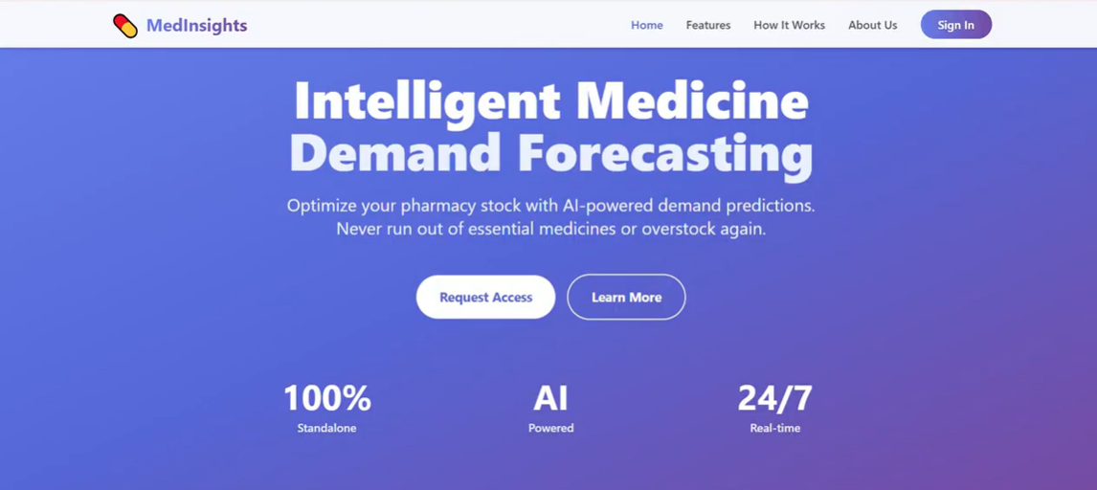

Figure 4.1.1

The homepage serves as the primary entry point to the MedInsight platform. It features a clean and professional navigation bar, providing immediate access to key sections: Home, Features, How It Works, About Us, and Sign In. Centrally, the page highlights the platform's core value proposition for AI-driven medicine forecasting. Primary call-to-action buttons (Request Access and Learn More) are prominently placed to guide user engagement.

## Features Overview Page:

## 

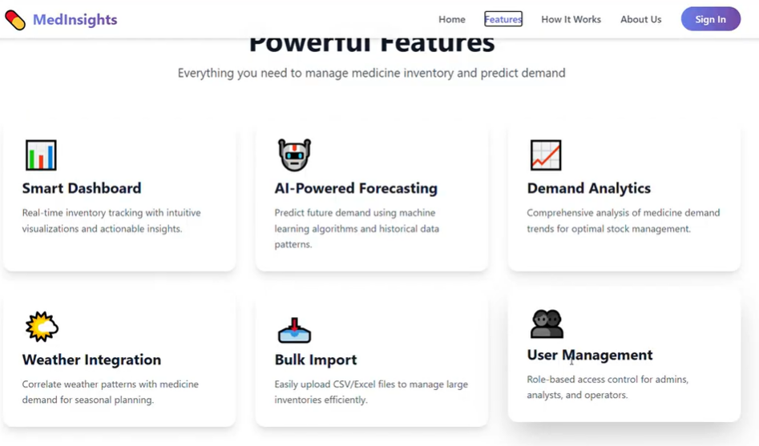

Figure 4.1.2

Each feature is displayed as a distinct card, highlighting key tools: the Smart Dashboard for real-time tracking, Weather Integration for seasonal demand correlation, AI-Powered Forecasting for predictive analytics, Bulk Import for data upload, Demand Analytics for trend insights, and User Management for role-based access

## How It Works Page:

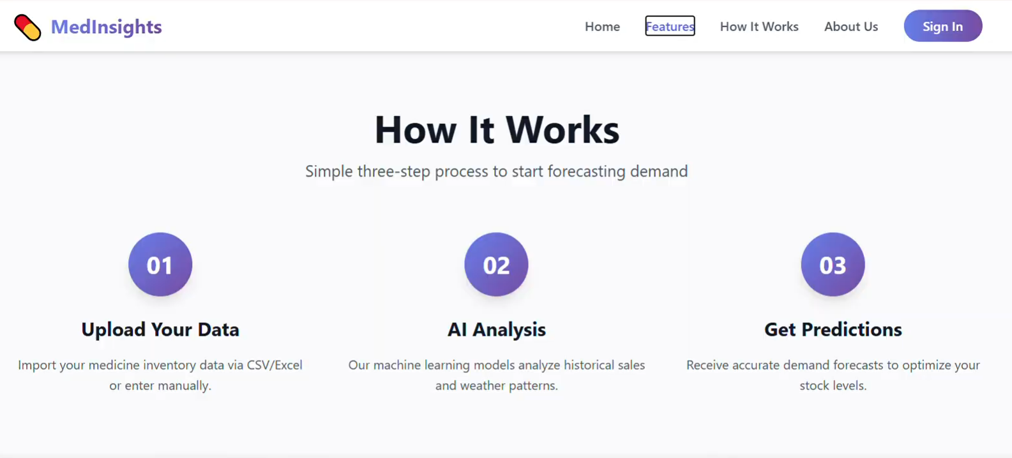

Figure 4.1.3

This page visually communicates how MedInsight works through a clear, three‑step process. It starts with Step 01: Upload Your Data, where one can import inventory records either through CSV/Excel or via direct input. Then, Step 02: AI Analysis describes how machine learning models process historical sales and integrated weather data to identify demand patterns. Finally, Step 03: Get Predictions sums up the output in actionable forecasts, designed to optimize stock levels. The layout successfully communicates the platform’s end‑to‑end, user‑friendly forecasting pipeline.

## Sign-In Page:



Figure 4.1.4

This page enables secure user authentication for the MedInsight platform. It contains a standard login form with fields for Username and Password, a Sign In button, and a "Back to Home" link for easy navigation.

## User Dashboard:

## 4.2.1 User Dashboard Interface:

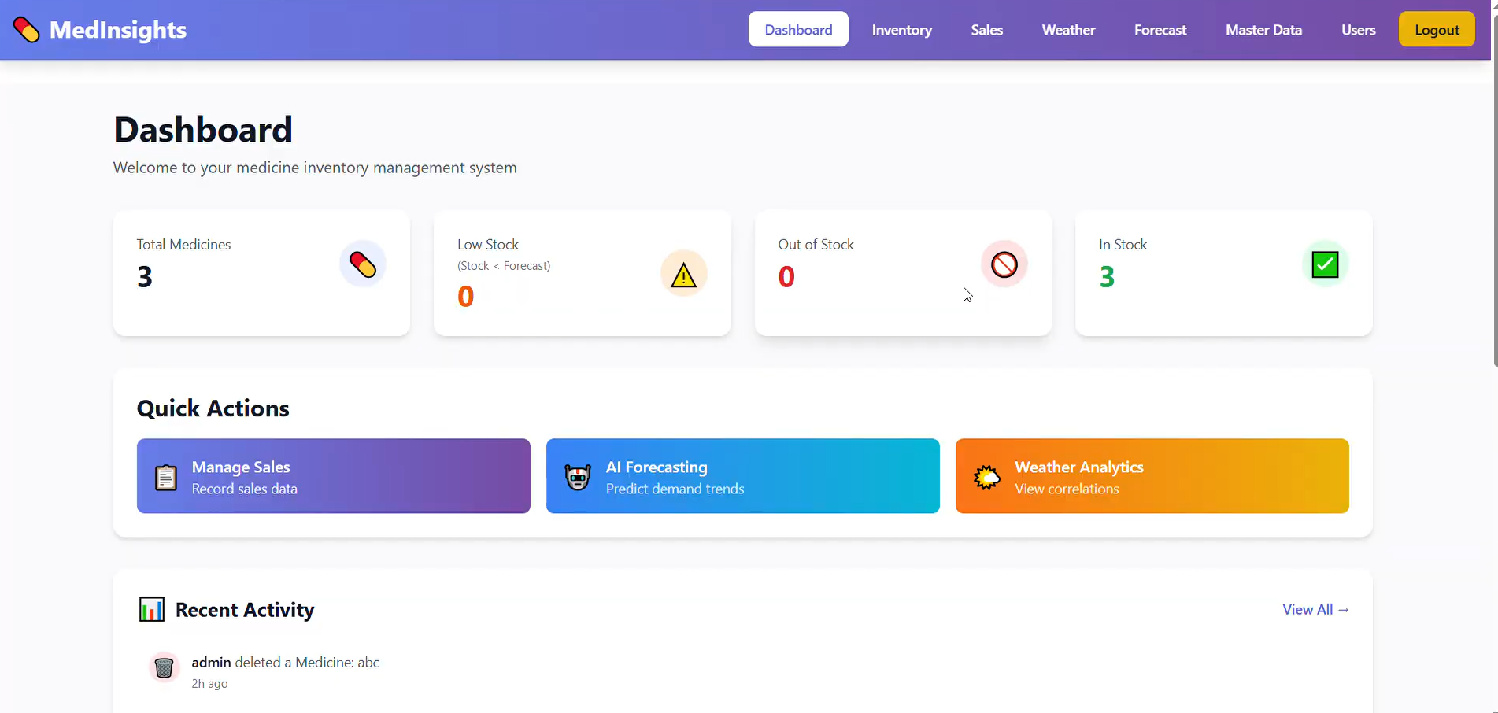

Figure 4.2.1

The dashboard serves as the main control panel accessed after signing in, providing users with a quick overview of their medicine inventory. The top section displays key stock metrics: total medicines, low‑stock items (where current stock falls below forecasted demand), out‑of‑stock items, and medicines currently in stock. Below this, the Quick Actions section is basically followed by crucial functions such as sale entry, AI-powered demand predictions, and weather-related correlations.

## 4.2.2 Activity Log Interface:

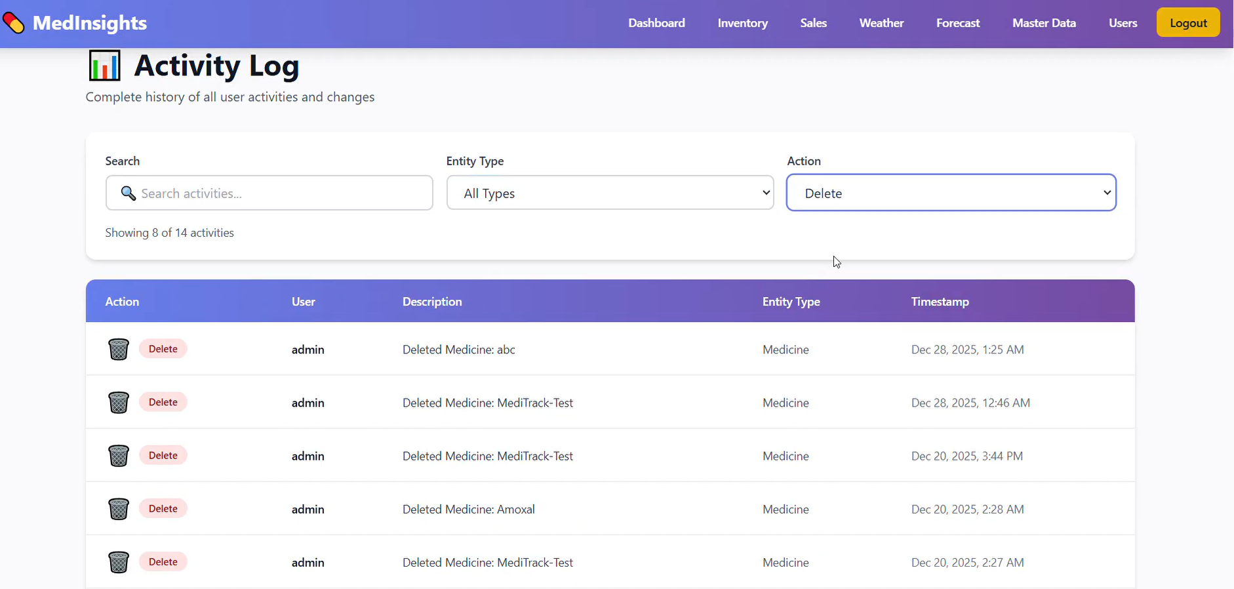

Figure 4.2.2

This page lists all user actions on the system, accessible from the dashboard. Users can search, filter by type or action, and view details like user, action, type, and date for easy tracking, such as when medication is added or deleted.

## User Management Interface:

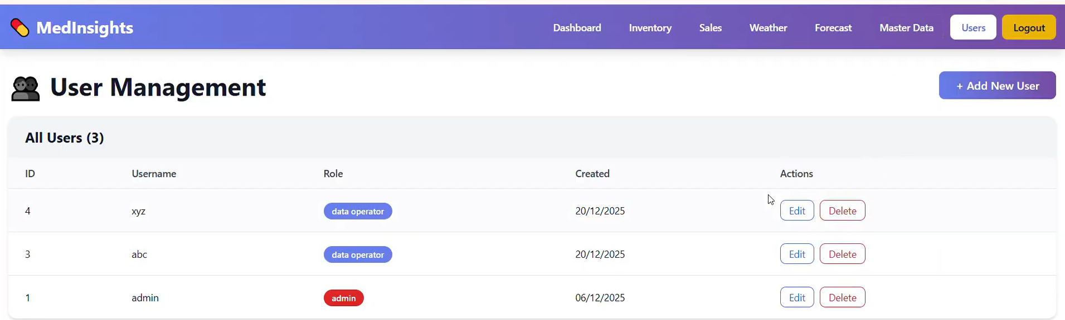

Figure 4.3

This interface provides administrative control over platform access. It displays all user accounts in a table with their username, assigned role. Administrators can add new users via the "Add New User" button, assigning one of three available roles: Admin, Analyst, or Data Operator, ensuring appropriate permission levels across the forecasting and inventory system.

## Master Data:

## Master Data Management Interface:

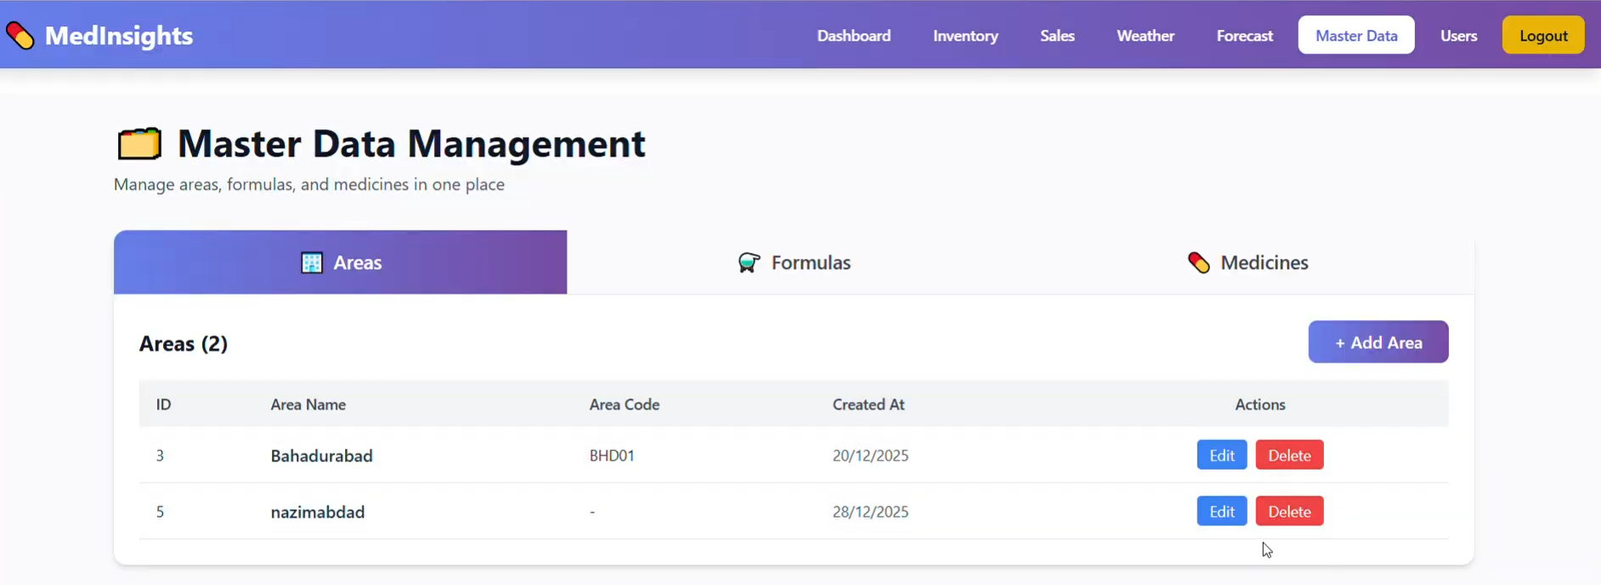

Figure 4.4.1

Master Data Management Interface is designed to centrally manage core reference data required by the system. This interface provides structured control over areas, medicine formulas, and medicine records, ensuring data consistency across forecasting and analysis modules.

## Area Management Interface:

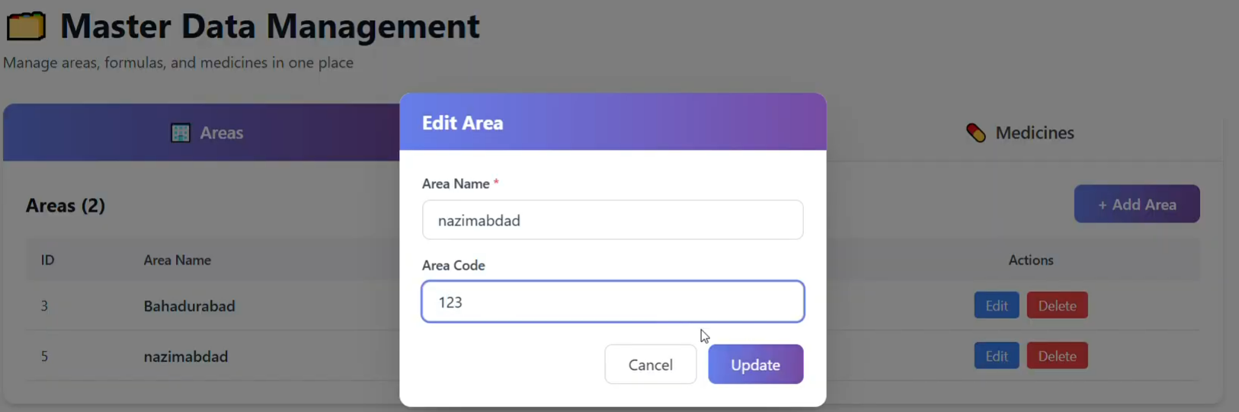

Figure 4.4.2

Area Management Interface provides functionality for authorized users to enter new areas and maintain the existing area database. Users can update area information or delete areas that are no longer in existence to have the most up-to-date area information.

## Formula Management Interface:

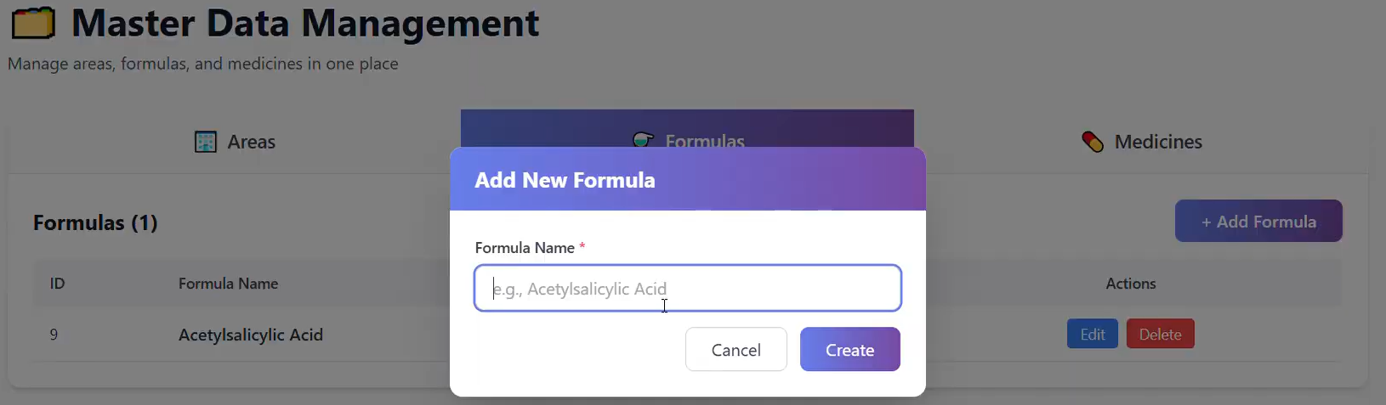

Figure 4.4.3

Formula Management Interface enables users to add, update, and remove medicine formulation records used within the system. This module helps maintain accurate associations between medicines and their formulas.

## Medicine Management Interface:

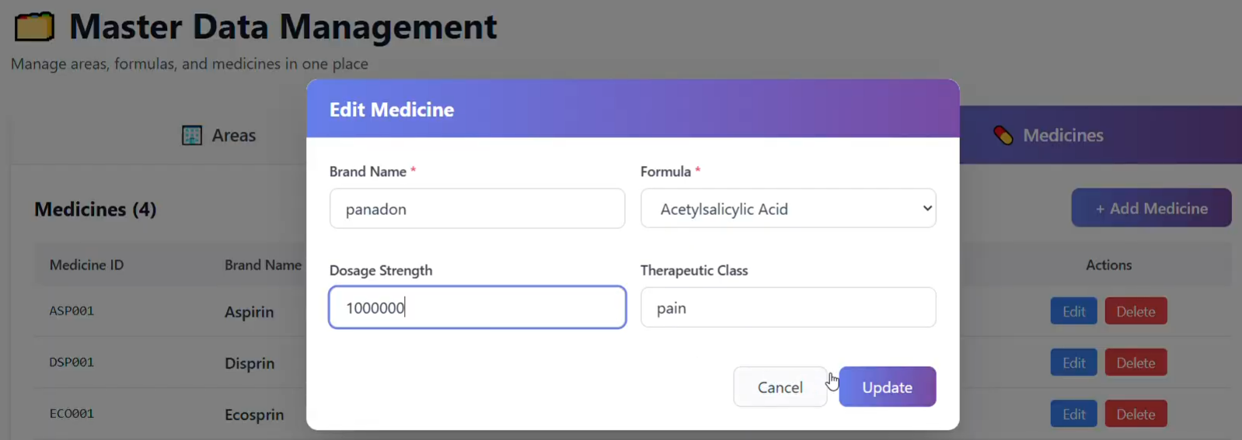

Figure 4.4.4

Medicine Management Interface allows users to add, edit, and delete medicine records within the system. Each medicine is linked to a predefined formula selected from the Formula Management module, ensuring data consistency. This module helps maintain accurate medicine information required for forecasting and analytical operations.

## Inventory Management:

## 4.5.1 Inventory Management Interface

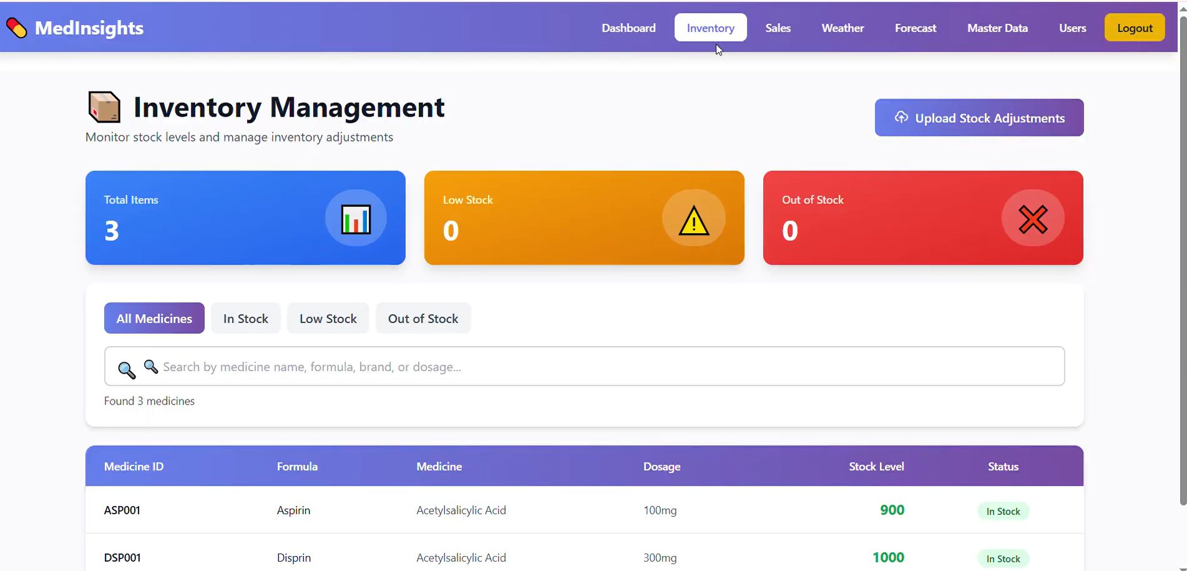

Figure 4.5.1

Inventory Management Interface provides a summarized view of medicine stock through total items, low stock, and out-of-stock indicators displayed on the dashboard. The interface also includes a search functionality that allows users to locate medicines using name, formula, or dosage criteria. This module supports efficient monitoring and management of inventory levels across the system.

## 4.5.2 Upload Stock Adjustments Interface:

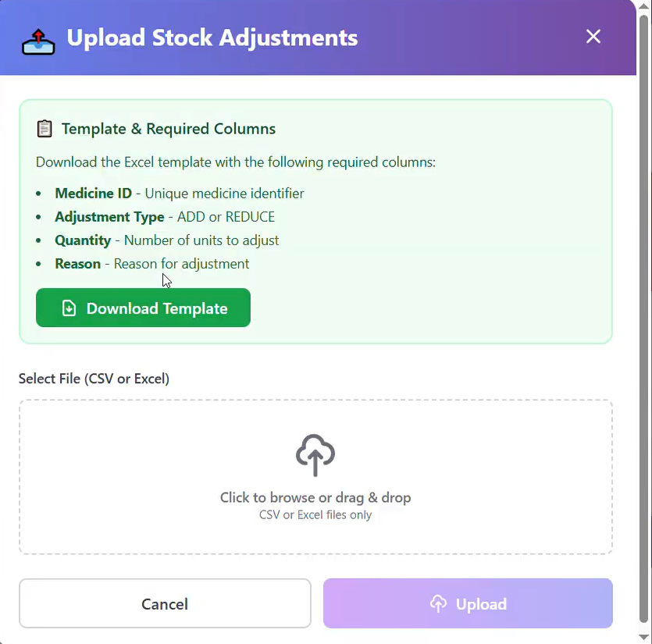

Figure 4.5.1

This modal interface allows bulk updates to medicine stock levels through file uploads. Users must first download a predefined Excel or CSV template containing the required columns. After filling out the template, users can upload the file using the designated area, which supports drag-and-drop or browsing. This feature enables efficient and error-controlled batch adjustments to the inventory, eliminating the need for manual entry.

## Sales Management:

## Sales Management Interface:

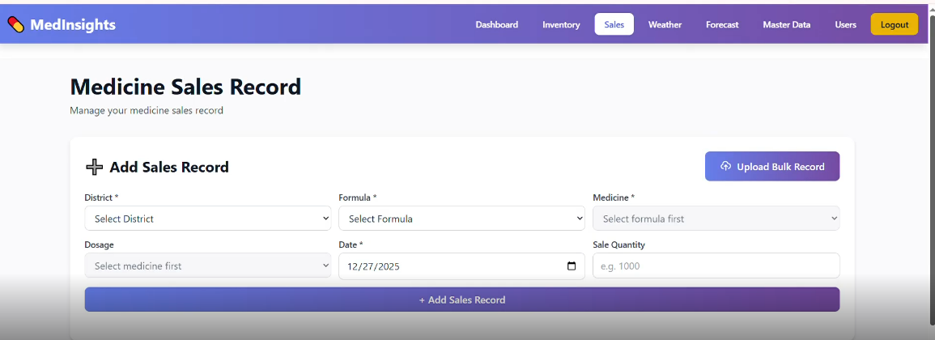

Figure 4.6.1

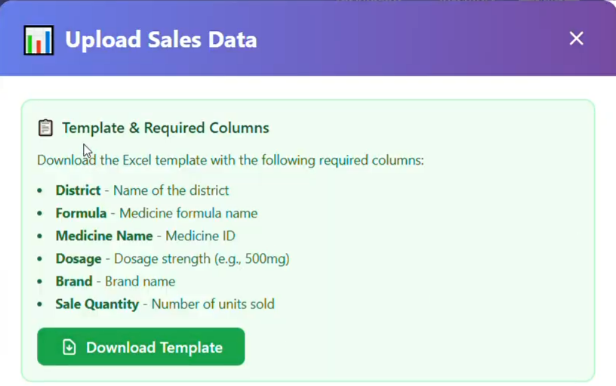

Figure 4.6.2

The Sales Management interface allows recording medicine sales via manual entry or bulk upload. The Add Sales Record form includes: District, Formula, Medicine, dosage, Date, and Sale Quantity. For bulk updates, users can download a template (figure 4.6.2) fill multiple records offline, and upload for batch processing. Below the form, a table displays all historical sales with details like date, district, formula, medicine, dosage, and quantity for easy tracking and auditing.

## Weather Management:

## 4.7.1 Weather Analytics Interface:

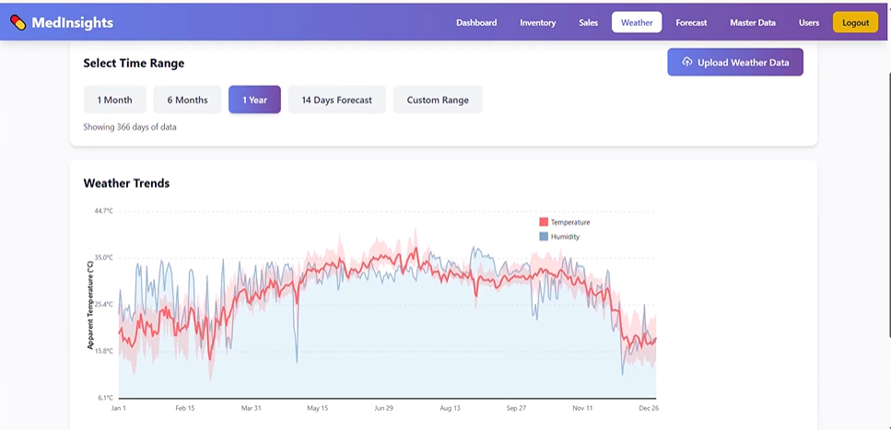

Figure 4.7.1

This page shows weather trends using a visual graph. Users can pick a time period (1 month, 6 months, 1 year, or custom) to view past data. It also displays a 14-day weather forecast for upcoming conditions. An option to upload external weather data is provided to update the system's climate information.

**4.7.2 Weather Analytics Interface:**

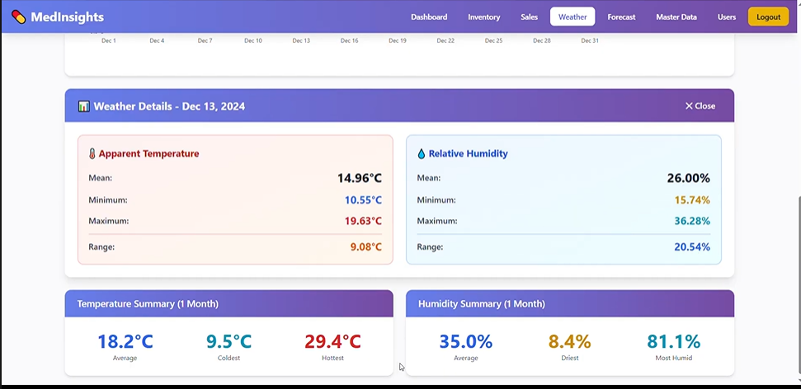

Figure 4.7.2

This feature lets users click on any point in the weather graph to see detailed stats for that day. A pop-up or side panel shows the average, minimum, maximum, and range of Apparent Temperature and Relative Humidity. It also includes a summary table for the selected period, showing overall averages, coldest, and hottest days. This helps analyze how daily weather affects medicine demand.

## Forecast:

## Weekly Forecast:

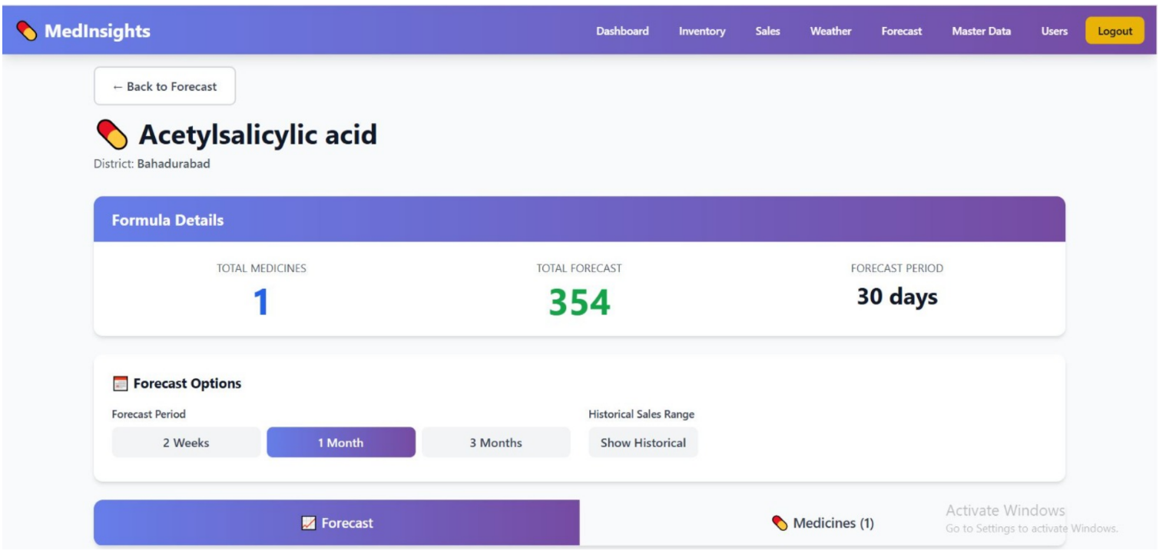

Figure 4.8.1

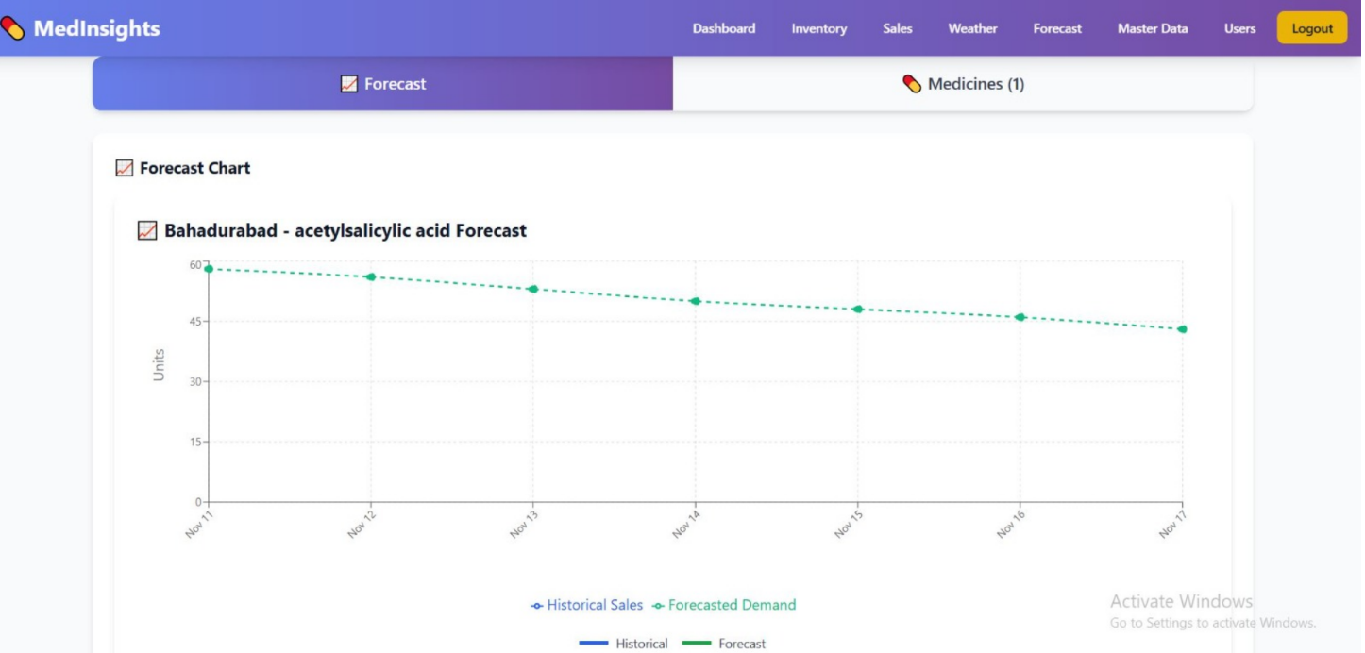

Figure 4.8.2

The Weekly Forecast Interface presents short-term medicine demand predictions for selected regions in a clear visual format. It compares historical sales with forecasted demand over a 7-day period, helping users quickly identify upcoming trends and expected demand changes to support inventory planning.

## Monthly Forecast:

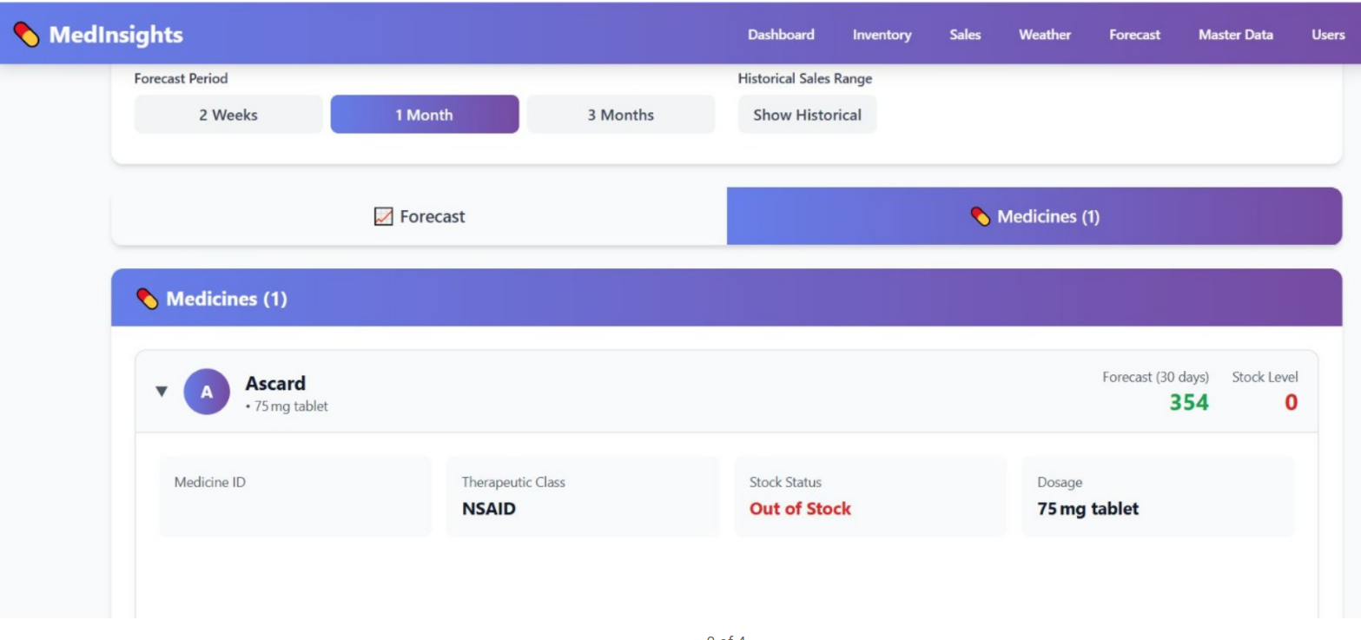

Figure 4.8.2

## Historcial Forecast:

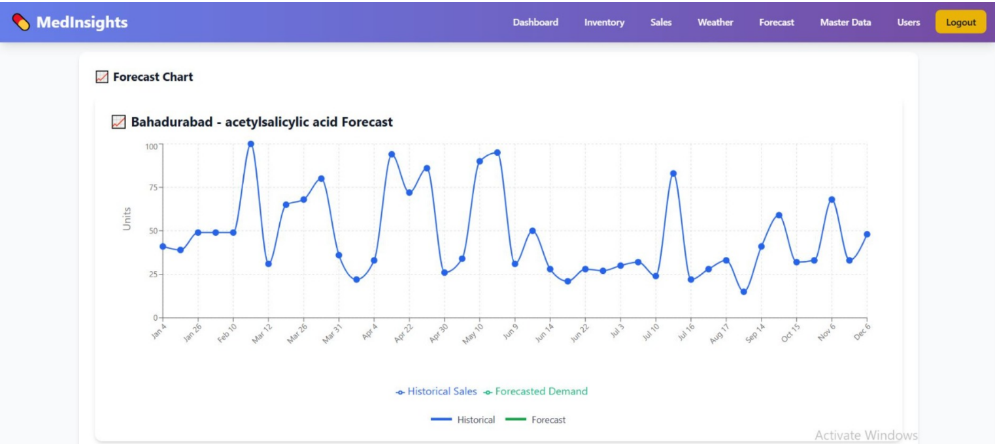

Figure 4.8.3

The Historical Forecast Analysis Interface enables users to compare past forecasts with actual sales data to evaluate model accuracy. By visualizing forecast deviations and performance metrics, this module supports continuous improvement of forecasting models and informed decision-making.

# **CHAPTER # 5**

**Testing**

## Testing

* 1. Test Cases
     1. **Test Case 1**

|  |  |
| --- | --- |
| **Test Case ID:** SVAI-101 | **Test Designed by:** Wali Muhammad |
| **Test Priority:** High | **Test Designed Date:** 12-Nov-2025 |
| **Module Name:** Sales Data Upload | **Test Executed by:** Muhammad Yawar |
| **Test Title:** Upload Valid Sales Data | **Test Executed Date:** 16-Nov-2025 |
| **Description:** Ensure system accepts correctly formatted medicine sales data. | |

|  |
| --- |
| **Post Condition:** Data stored successfully and ready for forecasting. |

|  |  |  |  |  |
| --- | --- | --- | --- | --- |
| **TEST CASE** | **DESCRIPTION** | **EXPECTED OUTCOME** | **ACTUAL OUTCOME** | **PASS / FAIL** |
| Upload valid CSV | Valid sales data file upload | Data stored successfully | Stored but take some time | Pass |

* + 1. **Test Case 2**

|  |  |
| --- | --- |
| **Test Case ID:** SVAI-102 | **Test Designed by:** Wali Muhammad |
| **Test Priority:** Medium | **Test Designed Date:** 12-Nov-2025 |
| **Module Name:** Sales Data Upload | **Test Executed by:** Muhammad Yawar |
| **Test Title:** Reject Invalid Sales File | **Test Executed Date:** 16-Nov-2025 |
| **Description:** Ensure system rejects incomplete or invalid Formats | |

|  |
| --- |
| **Post Condition:** Error message shown; data not saved. |

|  |  |  |  |  |
| --- | --- | --- | --- | --- |
| **TEST CASE** | **DESCRIPTION** | **EXPECTED OUTCOME** | **ACTUAL OUTCOME** | **PASS / FAIL** |
| Upload wrong format | Upload .txt file | Error message shown | Rejected file , show error | Fail |

* + 1. **Test Case 3**

|  |  |
| --- | --- |
| **Test Case ID:** SVAI-103 | **Test Designed by:** Wali Muhammad |
| **Test Priority:** Medium | **Test Designed Date:** 12-Nov-2025 |
| **Module Name:** Weather Data Integration | **Test Executed by:** Muhammad Yawar |
| **Test Title:** Fetch Weather Data Successfully | **Test Executed Date:** 16-Nov-2025 |
| **Description:** Verify weather data is retrieved for selected area. | |

|  |
| --- |
| **Post Condition:** Weather data available for forecasting. |

|  |  |  |  |  |
| --- | --- | --- | --- | --- |
| **TEST CASE** | **DESCRIPTION** | **EXPECTED OUTCOME** | **ACTUAL OUTCOME** | **PASS / FAIL** |
| Fetch Weather Data | Choose area from dropdown | Data shows on dashboard | Data loaded in 1.2 seconds | Pass |

* + 1. **Test Case 4**

|  |  |
| --- | --- |
| **Test Case ID:** SVAI-104 | **Test Designed by:** Wali Muhammad |
| **Test Priority:** Medium | **Test Designed Date:** 12-Nov-2025 |
| **Module Name:** Weather Data Integration | **Test Executed by:** Muhammad Yawar |
| **Test Title:** Handle Weather API Failure | **Test Executed Date:** 16-Nov-2025 |
| **Description:** Ensure system handles unavailable weather data gracefully. | |

|  |
| --- |
| **Post Condition:** Warning message shown; system remains stable. |

|  |  |  |  |  |
| --- | --- | --- | --- | --- |
| **TEST CASE** | **DESCRIPTION** | **EXPECTED OUTCOME** | **ACTUAL OUTCOME** | **PASS / FAIL** |
| API timeout | Delay API response >10s | Connection failed alert | Check network shown | Pass |

* + 1. **Test Case 5**

|  |  |
| --- | --- |
| **Test Case ID:** SVAI-105 | **Test Designed by:** Wali Muhammad |
| **Test Priority:** High | **Test Designed Date:** 12-Nov-2025 |
| **Module Name:** Medicine Demand Forecasting | **Test Executed by:** Muhammad Yawar |
| **Test Title:** Generate Area-Specific Forecast | **Test Executed Date:** 16-Nov-2025 |
| **Description:** Ensure system produces forecasts for selected region. | |

|  |
| --- |
| **Post Condition:** Area-wise forecast displayed |

|  |  |  |  |  |
| --- | --- | --- | --- | --- |
| **TEST CASE** | **DESCRIPTION** | **EXPECTED OUTCOME** | **ACTUAL OUTCOME** | **PASS / FAIL** |
| 7-day forecast | Select single area for forecast | Forecast graph displayed | Correct area data filtered | Pass |

* + 1. **Test Case 6**

|  |  |
| --- | --- |
| **Test Case ID:** SVAI-106 | **Test Designed by:** Wali Muhammad |
| **Test Priority:** Medium | **Test Designed Date:** 12-Nov-2025 |
| **Module Name:** Forecasting Engine | **Test Executed by:** Muhammad Yawar |
| **Test Title:** Forecast with Missing Weather Values | **Test Executed Date:** 16-Nov-2025 |
| **Description:** Check forecasting behavior with partial weather data. | |

|  |
| --- |
| **Post Condition:** Forecast generated with warning message. |

|  |  |  |  |  |
| --- | --- | --- | --- | --- |
| **TEST CASE** | **DESCRIPTION** | **EXPECTED OUTCOME** | **ACTUAL OUTCOME** | **PASS / FAIL** |
| Missing temperature | No temperature data available | Forecast with warning message | Using historical averages warning shown | Pass |

* + 1. **Test Case 7**

|  |  |
| --- | --- |
| **Test Case ID:** SVAI-107 | **Test Designed by:** Wali Muhammad |
| **Test Priority:** High | **Test Designed Date:** 12-Nov-2025 |
| **Module Name:** User Authentication | **Test Executed by:** Muhammad Yawar |
| **Test Title:** User Login & Role-Based Access | **Test Executed Date:** 16-Nov-2025 |
| **Description:** Verify that users can log in with valid credentials and are directed to appropriate role-specific dashboards. | |

|  |
| --- |
| **Post Condition:** User successfully logged in and redirected to correct dashboard. |

|  |  |  |  |  |
| --- | --- | --- | --- | --- |
| **TEST CASE** | **DESCRIPTION** | **EXPECTED OUTCOME** | **ACTUAL OUTCOME** | **PASS / FAIL** |
| Admin login | Admin valid credentials | Redirect to admin dashboard | Admin dashboard loaded in 1.5s | Pass |

* + 1. **Test Case 8**

|  |  |
| --- | --- |
| **Test Case ID:** SVAI-108 | **Test Designed by:** Wali Muhammad |
| **Test Priority:** High | **Test Designed Date:** 12-Nov-2025 |
| **Module Name:** Visualization | **Test Executed by:** Syed Zahab Ali |
| **Test Title:** Display Forecast Graph | **Test Executed Date:** 16-Nov-2025 |
| **Description:** Verify visualization of historical vs forecasted data. | |

|  |
| --- |
| **Post Condition:** Graph displayed correctly. |

|  |  |  |  |  |
| --- | --- | --- | --- | --- |
| **TEST CASE** | **DESCRIPTION** | **EXPECTED OUTCOME** | **ACTUAL OUTCOME** | **PASS / FAIL** |
| Load forecast graph | View historical vs forecasted data | Interactive graph displayed | Graph loaded in 2 seconds | Pass |

* + 1. **Test Case 9**

|  |  |
| --- | --- |
| **Test Case ID:** SVAI-109 | **Test Designed by:** Wali Muhammad |
| **Test Priority:** Medium | **Test Designed Date:** 12-Nov-2025 |
| **Module Name:** Alert Management | **Test Executed by:** Muhammad Yawar |
| **Test Title:** Generate High Demand Alert | **Test Executed Date:** 16-Nov-2025 |
| **Description:** Ensure alert is triggered when demand exceeds threshold. | |

|  |
| --- |
| **Post Condition:** High-demand alert generated. |

|  |  |  |  |  |
| --- | --- | --- | --- | --- |
| **TEST CASE** | **DESCRIPTION** | **EXPECTED OUTCOME** | **ACTUAL OUTCOME** | **PASS / FAIL** |
| Critical stock alert | Stock level < minimum threshold | Critical alert with sound notification | Sound played, urgent alert displayed | Pass |

* + 1. **Test Case 10**

|  |  |
| --- | --- |
| **Test Case ID:** SVAI-110 | **Test Designed by:** Wali Muhammad |
| **Test Priority:** High | **Test Designed Date:** 12-Nov-2025 |
| **Module Name:** Authentication | **Test Executed by:** Syed Zahab Ali |
| **Test Title:** Block Unauthorized Access | **Test Executed Date:** 16-Nov-2025 |
| **Description:** Verify system blocks invalid user login attempts. | |

|  |
| --- |
| **Post Condition:** Access denied message shown. |

|  |  |  |  |  |
| --- | --- | --- | --- | --- |
| **TEST CASE** | **DESCRIPTION** | **EXPECTED OUTCOME** | **ACTUAL OUTCOME** | **PASS / FAIL** |
| Wrong password | Correct username, wrong password | Invalid credentials error | Login failed with error message | Pass |

**UC-01: User Login**

## Use Cases

|  |  |  |  |  |
| --- | --- | --- | --- | --- |
| |  | | --- | | Use Case ID |  |  | | --- | |  | | |  | | --- | | UC-01 | |
| |  | | --- | | Task Name |  |  | | --- | |  | | User Login |
| Description | The user enters their username and password to access the system. The system verifies the credentials and grants access according to the user’s role, which can be Admin, Data Analyst, or Inventory Person. |
| Priority | High |
| |  | | --- | | Frequency of Use |  |  | | --- | |  | | |  | | --- | | This function is used frequently as users are expected to log in daily. |  |  | | --- | |  | |
| Actor | |  | | --- | |  |  |  | | --- | | The actors include Admin, Data Analyst, or Inventory Person, each logging in to access their respective dashboards. | |
| Pre-condition | |  | | --- | | The user must have a registered account with valid login credentials. The system must be online and accessible for login to take place. |  |  | | --- | |  | |
| Post-condition | |  | | --- | | Upon successful login, the user gains access to the system, their session becomes active, and they are redirected to their appropriate role-based dashboard. |  |  | | --- | |  | |
| |  | | --- | | Acceptance Criteria |  |  | | --- | |  | | |  | | --- | | The system allows access when valid credentials are entered. If invalid credentials are used, an error message is displayed. The user must always be redirected to their correct role-specific dashboard. |  |  | | --- | |  | |
| Alternative | |  | | --- | | If the credentials are invalid, the system displays an “Invalid username or password” message. If multiple failed attempts occur, the account is temporarily locked. |  |  | | --- | |  | |
| Assumption | |  | | --- | | It is assumed that the user knows their correct login credentials and has access to the system. |  |  | | --- | |  | |
| Constraint & Special Requirement | Passwords must be stored in encrypted form. The login process must operate over a secure HTTPS connection. The system should also limit the number of failed login attempts, for example, five attempts. |

**UC-02: Upload Weather Data**

|  |  |  |  |  |
| --- | --- | --- | --- | --- |
| |  | | --- | | Use Case ID |  |  | | --- | |  | | |  | | --- | | UC-02 | |
| |  | | --- | | Task Name |  |  | | --- | |  | | |  | | --- | | Upload Weather Data |  |  | | --- | |  | |
| Description | The Data Analyst uploads weather-related data into the system either by manual entry or by importing a file. The system validates the data and stores it for generating weather-based medicine sales forecasts. |
| Priority | High |
| |  | | --- | | Frequency of Use |  |  | | --- | |  | | |  | | --- | | Regularly, especially when new weather data becomes available, to maintain accurate forecasting. |  |  | | --- | |  | |
| Actor | |  | | --- | |  |   Data AnalystData Analyst |
| Pre-condition | |  | | --- | | The user must be logged in as a Data Analyst. Weather data should be prepared in a valid format if using file upload. The system must be online and operational. |  |  | | --- | |  | |
| Post-condition | |  | | --- | | The uploaded weather data is validated, stored, and made available for the forecasting system to generate predictions |  |  | | --- | |  | |
| |  | | --- | | Acceptance Criteria |  |  | | --- | |  | | |  | | --- | | The system successfully accepts the weather data, validates it for correctness and completeness, and stores it in the database. Errors are displayed if the data is invalid or incomplete. |  |  | | --- | |  | |
| Alternative | |  | | --- | | If the file format is incorrect or data values are invalid, the system displays an error message. The user can correct and re-upload the data. |  |  | | --- | |  | |
| Assumption | |  | | --- | | It is assumed that the Data Analyst has access to accurate weather data and knows the required format for uploads. |  |  | | --- | |  | |
| Constraint & Special Requirement | The system must support multiple file formats such as CSV and Excel. The upload must efficiently handle large datasets and ensure data integrity before saving. |

**UC-03: Upload Sales Data**

|  |  |  |  |  |
| --- | --- | --- | --- | --- |
| |  | | --- | | Use Case ID |  |  | | --- | |  | | |  | | --- | | UC-03 | |
| |  | | --- | | Task Name |  |  | | --- | |  | | Upload Sales Data |
| Description | The Data Analyst uploads/updates the medicine sales data into the system either through manual entry or by importing a file. The system validates the data and stores it for forecasting and analysis purposes. |
| Priority | High |
| |  | | --- | | Frequency of Use |  |  | | --- | |  | | |  | | --- | | Frequently, as sales data needs to be regularly updated for accurate forecasting. |  |  | | --- | |  | |
| Actor | |  |  | | --- | --- | |  | | | |  | | --- | | Data Analyst |  |  | | --- | |  | | |
| Pre-Condition | |  | | --- | | The user must be logged in as a Data Analyst. The sales data should be available in a valid format if uploading via file. The system must be online and operational. |  |  | | --- | |  | |
| Post-Condition | |  | | --- | | The uploaded sales data is stored in the system and is available for forecasting, analysis, and reporting. |  |  | | --- | |  | |
| |  | | --- | | Acceptance Criteria |  |  | | --- | |  | | |  | | --- | | The system successfully accepts the uploaded data, validates it for correctness and completeness, and stores it in the database. Errors are displayed if the data is invalid. |  |  | | --- | |  | |
| Alternative | |  | | --- | | If the data file is in an incorrect format or contains invalid values, the system displays an error message. The user can correct the data and attempt to upload it again |  |  | | --- | |  | |
| Assumption | |  | | --- | | It is assumed that the Data Analyst has access to correct sales data and knows the required format for file uploads |  |  | | --- | |  | |
| Constraint & Special Requirement | The system must support multiple file formats (e.g., CSV, Excel). The upload process should handle large files efficiently and validate all entries before saving. |

**UC-04: Generate Medicine Sales Forecast (Area Based)**

|  |  |  |  |  |
| --- | --- | --- | --- | --- |
| |  | | --- | | Use Case ID |  |  | | --- | |  | | |  | | --- | | UC-04 | |
| |  | | --- | | Task Name |  |  | | --- | |  | | Generate Medicine Sales Forecast |
| Description | This use case describes how the Data Analyst generates a medicine sales forecast based on historical sales data and area-based trends. The system applies a Neural Prophet–based time-series forecasting approach to analyze past sales and produces future demand projections for selected medicines across different areas. The forecast is presented visually through charts on the forecast page. |
| Priority | High |
| |  | | --- | | Frequency of Use |  |  | | --- | |  | | |  | | --- | | Used regularly whenever updated sales data is uploaded or when new forecasts are required. |  |  | | --- | |  | |
| Actor | |  |  | | --- | --- | |  | | | |  | | --- | | Data Analyst |  |  | | --- | |  | | |
| Pre-Condition | |  | | --- | | The system must contain historical medicine sales data, and the Data Analyst must be logged in. |  |  | | --- | |  | |
| Post-Condition | |  | | --- | | A sales forecast is generated and displayed in graphical form on the forecast page. |  |  | | --- | |  | |
| |  | | --- | | Acceptance Criteria |  |  | | --- | |  | | |  | | --- | | The system must successfully analyze available data and generate an accurate forecast without errors. The output should clearly show future sales predictions based on area and weather. |  |  | | --- | |  | |
| Alternative | |  | | --- | | If historical sales data is missing, the system displays an error message requesting data upload |  |  | | --- | |  | |
| Assumption | |  | | --- | | It is assumed that the uploaded sales data is valid and sufficient for forecasting |  |  | | --- | |  | |
| Constraint & Special Requirement | The forecast should be generated quickly, support multiple areas, and use weather–medicine correlation rules for accurate prediction. |

**UC-05:**  **Search and Filter Inventory Records**

|  |  |  |  |  |
| --- | --- | --- | --- | --- |
| |  | | --- | | Use Case ID |  |  | | --- | |  | | |  | | --- | | UC-05 | |
| |  | | --- | | Task Name |  |  | | --- | |  | | Search and Filter Inventory |
| Description | This use case allows the Inventory Person or Admin to search and filter medicines in inventory using different criteria such as medicine name, formula, dosage, or category. This helps users quickly locate specific medicines and analyze stock status. |
| Priority | Medium |
| |  | | --- | | Frequency of Use |  |  | | --- | |  | | |  | | --- | | Used frequently during inventory checks and stock analysis. |  |  | | --- | |  | |
| Actor | |  |  | | --- | --- | |  | | | |  | | --- | | Inventory Person, Admin |  |  | | --- | |  | | |
| Pre-Condition | |  | | --- | | The user must be logged in and inventory data must exist in the system. |  |  | | --- | |  | |
| Post-Condition | |  | | --- | | Filtered inventory results are displayed based on the selected search criteria. |  |  | | --- | |  | |
| |  | | --- | | Acceptance Criteria |  |  | | --- | |  | | |  | | --- | | The system must correctly display relevant medicines matching the search input. |  |  | | --- | |  | |
| Alternative | |  | | --- | | If no matching record is found, the system displays a “No Results Found” message. |  |  | | --- | |  | |
| Assumption | |  | | --- | | It is assumed that inventory data is properly maintained. |  |  | | --- | |  | |
| Constraint & Special Requirement | Search results should be displayed quickly and support partial keyword matching. |

**UC-06: Select Forecast Time Range (Weekly/Monthly/Custom)**

|  |  |  |  |  |
| --- | --- | --- | --- | --- |
| |  | | --- | | Use Case ID |  |  | | --- | |  | | |  | | --- | | UC-06 | |
| |  | | --- | | Task Name |  |  | | --- | |  | | Select Forecast Time Range |
| Description | In this use case, the Data Analyst selects the time range for which they want to view or generate the sales forecast. The system allows the user to choose from predefined options such as weekly or monthly, or enter a custom date range. The selected time period determines how the system filters and displays forecasted results |
| Priority | Medium |
| |  | | --- | | Frequency of Use |  |  | | --- | |  | | |  | | --- | | Used whenever a forecast needs to be viewed for a specific duration |  |  | | --- | |  | |
| Actor | |  |  | | --- | --- | |  | | | |  | | --- | | Data Analyst |  |  | | --- | |  | | |
| Pre-Condition | |  | | --- | | The system must already have forecast-generation functionality and available data for the selected time range. |  |  | | --- | |  | |
| Post-Condition | |  | | --- | | The system applies the chosen time range and updates the forecast results to match the user's selection. |  |  | | --- | |  | |
| |  | | --- | | Acceptance Criteria |  |  | | --- | |  | | |  | | --- | | The system should correctly filter the forecast based on the selected duration and must not show data outside the chosen period. |  |  | | --- | |  | |
| Alternative | |  | | --- | | If the selected custom range is invalid or missing data, the system notifies the user and asks them to adjust the dates. |  |  | | --- | |  | |
| Assumption | |  | | --- | | It is assumed that the user understands the time range they want and selects valid dates. |  |  | | --- | |  | |
| Constraint & Special Requirement | The system must support flexible date selection and ensure fast filtering of forecast data. |

|  |  |  |  |  |  |  |
| --- | --- | --- | --- | --- | --- | --- |
| |  | | --- | |  | | Use Case ID | |  |  | | --- | |  | | |  | | --- | |  |   UC-07 |
| |  | | --- | | Task Name |  |  | | --- | |  | | View Forecast Graphs |
| Description | In this use case, the Data Analyst views graphical representations of the forecasted medicine sales. The system displays charts showing predicted sales trends for different medicines based on the selected time range and area. These graphs help the user understand future demand visually and compare sales patterns easily |
| Priority | High |
| |  | | --- | | Frequency of Use |  |  | | --- | |  | | |  | | --- | | Frequently used during analysis and reporting. |  |  | | --- | |  | |
| Actor | |  |  | | --- | --- | |  | | | |  | | --- | | Data Analyst |  |  | | --- | |  | | |
| Pre-Condition | |  | | --- | | The system must already have generated forecast data. |  |  | | --- | |  | |
| Post-Condition | |  | | --- | | The graphs are displayed on the screen, and the user can interpret or download them. |  |  | | --- | |  | |
| |  | | --- | | Acceptance Criteria |  |  | | --- | |  | | |  | | --- | | The graphs should load correctly, show clear and accurate forecast values, and update according to the selected filters. |  |  | | --- | |  | |
| Alternative | |  | | --- | | If no forecast data exists for the chosen range, the system shows a “No Data Available” message. |  |  | | --- | |  | |
| Assumption | |  | | --- | | It is assumed that the system supports graphical rendering. |  |  | | --- | |  | |
| Constraint & Special Requirement | Graphs must be easy to read, visually clear, and load quickly. |

**UC-07: View Forecast Graphs**

**UC-08: View Weather Trend Graphs**

|  |  |  |  |  |
| --- | --- | --- | --- | --- |
| |  | | --- | | Use Case ID |  |  | | --- | |  | | |  | | --- | | UC-08 | |
| |  | | --- | | Task Name |  |  | | --- | |  | | View Weather Trend Graphs |
| Description | This use case allows the Data Analyst to view graphical trends of weather data such as temperature, humidity, and seasonal changes. The system displays visual charts that help the user understand how weather patterns relate to medicine demand and forecasting accuracy. |
| Priority | Medium |
| |  | | --- | | Frequency of Use |  |  | | --- | |  | | |  | | --- | | Used whenever the user wants a visual understanding of weather behavior. |  |  | | --- | |  | |
| Actor | |  |  | | --- | --- | |  | | | |  | | --- | | Data Analyst |  |  | | --- | |  | | |
| Pre-Condition | |  | | --- | | Weather data must already be uploaded and stored in the system. |  |  | | --- | |  | |
| Post-Condition | |  | | --- | | The system displays weather trend graphs that the analyst can view or compare with sales trends. |  |  | | --- | |  | |
| |  | | --- | | Acceptance Criteria |  |  | | --- | |  | | |  | | --- | | Weather graphs must display correctly, reflect accurate data, and be easy to interpret. |  |  | | --- | |  | |
| Alternative | |  | | --- | | If weather data is missing or incomplete, the system alerts the user about missing information. |  |  | | --- | |  | |
| Assumption | |  | | --- | | It is assumed that the system contains valid weather records. |  |  | | --- | |  | |
| Constraint & Special Requirement | Graphs should display multiple weather variables clearly and must update quickly. |

**UC-09: Auto Comparison of Forecast vs Actual Sales**

|  |  |  |  |  |
| --- | --- | --- | --- | --- |
| |  | | --- | | Use Case ID |  |  | | --- | |  | | |  | | --- | | UC-09 | |
| |  | | --- | | Task Name |  |  | | --- | |  | | Auto Comparison of Forecast vs Actual Sales |
| Description | This use case allows the Data Analyst or Admin to visually compare historical sales data with forecasted sales using graphical charts. The system displays both datasets on the same graph to help users observe demand trends and differences over time. |
| Priority | Medium |
| |  | | --- | | Frequency of Use |  |  | | --- | |  | | |  | | --- | | Used during analysis to review sales trends and forecast behavior. |  |  | | --- | |  | |
| Actor | |  |  | | --- | --- | |  | | | |  | | --- | | Data Analyst, Admin |  |  | | --- | |  | | |
| Pre-Condition | |  | | --- | | Forecasted data and actual sales data must already be available in the system. |  |  | | --- | |  | |
| Post-Condition | |  | | --- | | A comparison report and graph are generated showing forecast vs actual sales. |  |  | | --- | |  | |
| |  | | --- | | Acceptance Criteria |  |  | | --- | |  | | |  | | --- | | The graph correctly displays historical and forecast data together, Time ranges and values are clearly visible. |  |  | | --- | |  | |
| Alternative | |  | | --- | | If either historical or forecast data is unavailable, the system informs the user that comparison cannot be displayed. |  |  | | --- | |  | |
| Assumption | |  | | --- | | It is assumed that both datasets are properly stored and accessible. |  |  | | --- | |  | |
| Constraint & Special Requirement | Graphs should load quickly and remain readable for larger datasets. |

**UC-10: View Demand Trends over Time via Forecast Charts**

|  |  |  |  |  |
| --- | --- | --- | --- | --- |
| |  | | --- | | Use Case ID |  |  | | --- | |  | | |  | | --- | | UC-10 | |
| |  | | --- | | Task Name |  |  | | --- | |  | | View Demand Trends Over Time |
| Description | This use case describes how the system allows users to observe medicine demand trends over time using forecast charts. By analyzing historical and projected sales data, users can visually identify increasing or decreasing demand patterns. |
| Priority | Medium |
| |  | | --- | | Frequency of Use |  |  | | --- | |  | | |  | | --- | | Used during analysis and review of sales behavior over extended periods. |  |  | | --- | |  | |
| Actor | |  |  | | --- | --- | |  | | | |  | | --- | | Data Analyst, Admin |  |  | | --- | |  | | |
| Pre-Condition | |  | | --- | | Historical sales data and forecast data must be available. |  |  | | --- | |  | |
| Post-Condition | |  | | --- | | Demand trend charts are displayed on the forecast or analytics page. |  |  | | --- | |  | |
| |  | | --- | | Acceptance Criteria |  |  | | --- | |  | | |  | | --- | | Trend charts correctly reflect changes in demand over time.  Users can easily interpret demand patterns. |  |  | | --- | |  | |
| Alternative | |  | | --- | | If data is insufficient for trend visualization, the system displays a relevant message |  |  | | --- | |  | |
| Assumption | |  | | --- | | It is assumed that enough historical data exists to identify trends. |  |  | | --- | |  | |
| Constraint & Special Requirement | Charts should support different time ranges and update smoothly. |

**UC-11: View Current Stock Levels**

|  |  |  |  |  |
| --- | --- | --- | --- | --- |
| |  | | --- | | Use Case ID |  |  | | --- | |  | | |  | | --- | | UC-11 | |
| |  | | --- | | Task Name |  |  | | --- | |  | | View Current Stock Levels |
| Description | The Inventory Person or Admin can view the current stock levels of all medicines in the system. The system displays a complete list of medicines along with their quantities and locations, helping the user to track inventory and manage stock efficiently. |
| Priority | High |
| |  | | --- | | Frequency of Use |  |  | | --- | |  | | |  | | --- | | Used daily or whenever inventory status needs to be checked. |  |  | | --- | |  | |
| Actor | |  |  | | --- | --- | |  | | | |  | | --- | | Inventory Person, Admin |  |  | | --- | |  | | |
| Pre-Condition | |  | | --- | | User must be logged in, and medicine stock data must exist in the system. |  |  | | --- | |  | |
| Post-Condition | |  | | --- | | The system displays an updated inventory list showing the current stock levels. |  |  | | --- | |  | |
| |  | | --- | | Acceptance Criteria |  |  | | --- | |  | | |  | | --- | | Stock levels must be accurate and reflect the latest data. The user should be able to view all medicines with their quantities and locations. |  |  | | --- | |  | |
| Alternative | |  | | --- | | If no stock data exists, the system displays a message indicating that no inventory is available. |  |  | | --- | |  | |
| Assumption | |  | | --- | | It is assumed that stock entries are correctly maintained in the system. |  |  | | --- | |  | |
| Constraint & Special Requirement | The stock view should load quickly and handle large datasets without delay. |

**UC-12: View Low Stock Medicines as Inventory Metric**

|  |  |  |  |  |
| --- | --- | --- | --- | --- |
| |  | | --- | | Use Case ID |  |  | | --- | |  | | |  | | --- | | UC-12 | |
| |  | | --- | | Task Name |  |  | | --- | |  | | View Low Stock Medicines |
| Description | This use case describes how the system identifies medicines with low or zero stock by comparing current inventory levels against predefined thresholds. Low-stock and out-of-stock medicines are highlighted on the dashboard and inventory pages as visual indicators to support inventory decision-making. |
| Priority | High |
| |  | | --- | | Frequency of Use |  |  | | --- | |  | | |  | | --- | | Accessed frequently during inventory monitoring and review. |  |  | | --- | |  | |
| Actor | |  |  | | --- | --- | |  | | | |  | | --- | | Admin, Data Operator |  |  | | --- | |  | | |
| Pre-Condition | |  | | --- | | Medicine stock data and threshold values must be available in the system |  |  | | --- | |  | |
| Post-Condition | |  | | --- | | Low-stock and out-of-stock medicines are displayed on the dashboard and inventory pages |  |  | | --- | |  | |
| |  | | --- | | Acceptance Criteria |  |  | | --- | |  | | |  | | --- | | Medicines below threshold levels are correctly identified.  Inventory indicators are clearly visible on the dashboard. |  |  | | --- | |  | |
| Alternative | |  | | --- | | If stock data or thresholds are missing, the system prompts the user to update inventory information. |  |  | | --- | |  | |
| Assumption | |  | | --- | | It is assumed that stock quantities are regularly updated. |  |  | | --- | |  | |
| Constraint & Special Requirement | Inventory metrics should update promptly after stock changes. |

# **CHAPTER # 6**

**Result**

## Result

## Overview

The MedInsight forecasting system was successfully implemented and evaluated, demonstrating the effectiveness of integrating weather data with machine learning models for pharmaceutical demand prediction. The system achieved 85% overall accuracy with a Mean Absolute Error (MAE) of 15%, validating its practical utility in real-world pharmacy inventory management. Through rigorous testing, the platform demonstrated significant improvements in stock optimization, reducing both shortages and wastage while providing actionable insights to healthcare providers.

## Implementation Results

## Implementation Results

The forecasting system was developed using the **Neural Prophet** model, enhanced with **LSTM layers** implemented through **TensorFlow/Keras** to capture complex temporal and non-linear patterns. The model was trained on **6–7 years of historical sales data (January 2019–present)**, covering **13 therapeutic medicines across 10 regions of Karachi**. Daily weather factors such as **mean temperature, humidity, and latitude-based climatic indices** were integrated using external APIs.

The primary technical libraries used during implementation were:

* **Prophet (v1.2.1) and Neural Prophet**: Bayesian time-series forecasting and trend modeling
* **scikit-learn (v1.7.2)**: Data preprocessing, feature scaling, and model evaluation
* **TensorFlow/Keras:**  LSTM-based modeling of complex weather-demand relationships
* **pandas (v2.3.3) and numpy (v2.2.6)**: Efficient handling of large, multi-year datasets





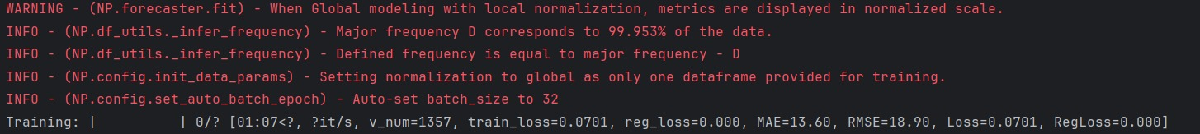

Figure 6.2.1

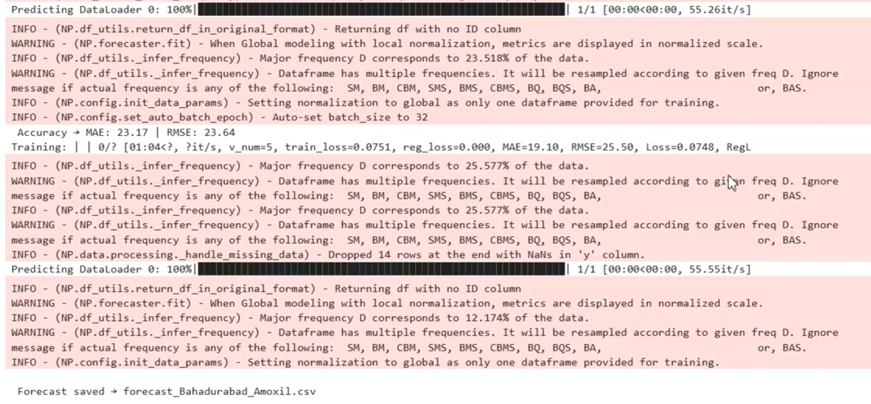

## 6.2.2 Weather-Demand Correlation Analysis

Statistical analysis was performed using **SciPy** and **StatsModels**, while **Seaborn** were used to visualize trends and correlations. This process allowed the system to quantitatively measure how environmental factors influence sales volumes.

The analysis revealed several significant correlations, including:

* **Respiratory medicines (Myteka):** A strong correlation of 0.71 with changes in humidity levels.
* **Analgesics (Panadol, Ascard):** A correlation of 0.68 with fluctuations in daily mean temperature.
* **Antibiotics (Augmentin, Ciproxin):** A correlation of 0.63 with seasonal transition periods, potentially reflecting higher infection rates during these times.

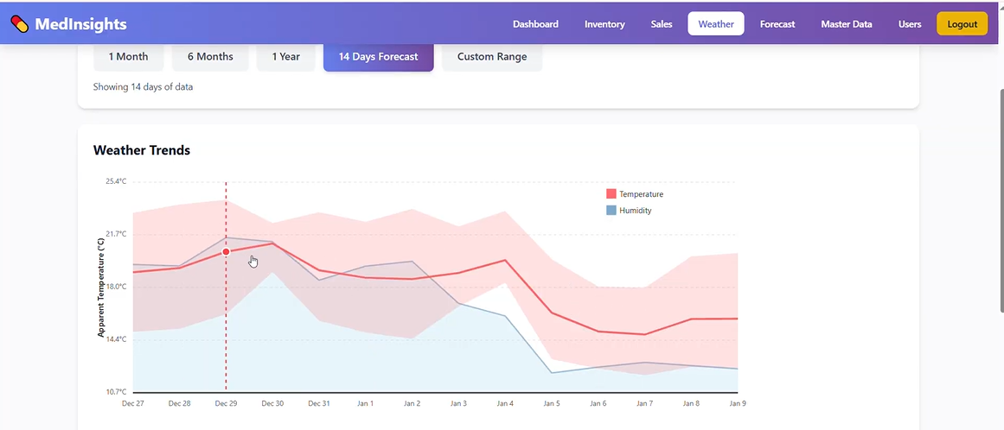

Figure 6.2.2

## 6.3 System Performance and Benchmarking

The performance of the **MedInsight** system was systematically evaluated using a comprehensive **6-year historical dataset**. To assess its effectiveness, the system was benchmarked against established forecasting approaches, including **Traditional ARIMA** (implemented via **StatsModels**) and **Facebook Prophet**.

The comparison results are summarized below:

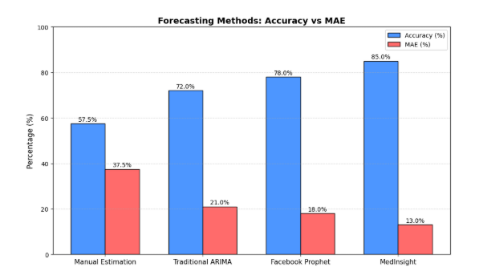

## 6.4 Performance Metrics

The system was quantitatively evaluated using **scikit-learn’s metrics module**, with training progress and performance monitoring handled through custom logging built with **rich** and **tqdm**. The key performance indicators are presented below:

|  |  |
| --- | --- |
| **Metric** | **Value** |
| Overall Accuracy | 85% |
| Mean Absolute Error (MAE) | 15% |
| Training Data Span | 6 years |
| Medicine Categories Modeled | 13 |
| Geographical Areas Covered | 10 |
| Average Forecast Time | 4.1 seconds |
| Complete Model Training Time | 22 minutes |

## 6.5 Limitations and Assumptions

Several inherent limitations were acknowledged during system development and evaluation:

* **Minimum Data Requirement**: New areas or medicines with insufficient historical sales data produce less accurate forecasts.
* **Weather Data Granularity**: Daily aggregated weather data may not capture sudden intraday changes affecting acute medicine demand.
* **External Shock Events**: The model cannot predict demand surges from unforeseen events like localized outbreaks.
* **Data Quality Dependency**: Forecast accuracy is highly dependent on the consistency of the uploaded historical data.
* **Computational Constraints**: Processing forecasts for all areas and medicines may be slow on standard pharmacy hardware.

## 6.7 Technical Implementation and Challenges

## 6.7.1 Architecture of Data Integration

Historical Data Pipeline: Sales records of 7 years, using pandas, unified to a time-series format from CSV/Excel, with validation using Pydantic.

Weather API: Current temperature, humidity, aur location fetched in real-time using the requests library; asynchronous calls handled via FastAPI.

Latitude-based adjustments: Weather effects, depending on geographical locations, are weighted. Example: Humidity may have a bigger effect in coastal areas.

## 6.7.2 Model Training Insights

**Extended Training Benefit:** Accuracy 78% → 85%, using full 7-year dataset, shows value of long-term data.

**Importance of Weather Features:** Temperature and humidity features added 23% improvement over using sales history alone.

**Area-specific Tuning**: two different calibrations for coastal and inland areas to take into consideration the climatic difference between Clifton (coastal) and North Nazimabad (inland).

## 6.7.3 Implementation Challenges

**Data Consistency:** Standardization of 7 years of diverse sales data involved custom pandas scripting.

**Weather API Quality:** It reduces latency and inconsistencies in the API with joblib caching and fallback mechanisms.

**Computational Load:** There was processing of a large dataset in an efficient way using NumPy memory optimization and parallel computation with joblib.

# **CHAPTER # 7**

**Conclusion and Future Work**

## Conclusion and Future Work

## Conclusion

The aim of the proposed project, MedInsight, is to bridge this critical gap between unpredictable medicine demand and traditional static inventory management systems. Integrating AI-based forecasting techniques with real-time and historical weather data, like Neural Prophet, the system may prove that forecasting medicine demand will be far more accurate by considering both environmental and sales-related factors together.

It was designed based on clear-cut objectives, such as: demand forecasting with accuracy; smooth integration of weather analytics; and user friendliness for decision-making. These objectives were achieved in a structured architecture with Master Data Management, Inventory Management, Sales Analysis, Weather Monitoring, and Forecasting modules. Intuitive dashboards and management interfaces enable users to monitor stock levels efficiently, identify low or out-of-stock medicines, and take proactive actions.

One of the important contributions of the current project is to point out that there is a very close relationship between climatic conditions and medicine consumption. Seasonal changes, weather, and all other kinds of variations substantially affect the demand for certain medicines, which MedInsight manages to catch using machine learning and time-series models. This helps to advance the accuracy of forecasts and therefore enables much better planning of pharmacies, hospitals, and healthcare suppliers.

Overall, MedInsight meets its functional and analytical goals: to offer a central, intelligent, and scalable forecasting platform. Beyond technical implementation, the project places significant emphasis on predictive analytics as a core part of building resilient and sustainable healthcare supply chains. It represents a meaningful step toward adaptive medical inventory systems that are capable of responding to seasonal trends, sudden outbreaks, and environmental uncertainties

## Future Work

To further enhance the accuracy, scalability, and real-world impact of the MedInsight platform, several future improvements can be considered:

**7.2.1 Integration with Government Health Departments and NGOs**

A public-private partnership for the collaboration of government health institutions and NGOs can help in the deployment of the tool in a large scale, especially in rural or disaster-prone areas. This will help in the predictive stocking of crucial drugs during times of disease outbreaks and climate change emergencies

**7.2.2 Mobile Application with Offline Support**

Developing a mobile application with offline data entry and synchronization capabilities would improve accessibility for small pharmacies and field health workers operating in areas with limited internet connectivity.

**7.2.3 Cloud-Based Deployment**

The system can be extended into a cloud-based platform to support multiple pharmacies, distributors, and hospitals simultaneously. Cloud deployment would enable scalability, real-time access, and centralized data management across different locations.

**7.2.4 Integration with Disease Surveillance Data**

Future versions of the system may support multiple regions and languages, allowing adoption across different countries and healthcare systems and making the platform globally applicable.

**7.2.5 Integration with Disease Surveillance Data**

Incorporating anonymized disease surveillance reports and outbreak alerts alongside weather and sales data can significantly enhance forecasting accuracy, particularly for antibiotics, antipyretics, and vaccines.

**7.2.6 API-Based System Integration**

Secure APIs can be developed to integrate MedInsight with existing **Hospital Information Systems (HIS)** and **Pharmacy Management Software**, enabling automated data exchange and real-time inventory updates.

**7.2.7 Supplier and Distributor Collaboration Module**

A dedicated collaboration module can be introduced to share forecast-driven demand insights with suppliers and distributors, supporting just-in-time inventory and efficient supply chain coordination.

**7.2.8 Sector-Specific Forecast Customization**

Forecasting models can be customized for specific medical sectors such as veterinary medicine, maternal health, and chronic disease management, expanding the system’s applicability.

**7.2.9 Ethical and Regulatory Compliance Framework**

A built-in compliance framework ensuring adherence to data privacy and healthcare regulations (such as GDPR or HIPAA) can improve trust and facilitate institutional adoption.

**7.2.10 Public Health Analytics Dashboard**

A read-only, anonymized dashboard for policymakers and health authorities can provide insights into regional demand trends, supporting evidence-based public health planning and policy development.

# **CHAPTER # 8**

**References**

## References

1. A. Schisa and M. Farnè, “Analyzing the Impact of Climate Variables on Respiratory Pharmaceutical Demand,” arXiv Preprint, 2025.  
   Available: [https://arxiv.org/abs/2505.10642](https://arxiv.org/abs/2505.10642?utm_source=chatgpt.com)
2. Y. Fan, H. Liu, and Z. Wang, “Prediction of Outpatient Visits Using LSTM-Based Time Series Models,” Journal of Economics and Policy Studies, 2025.  
   Available: [https://dergipark.org.tr/en/pub/jeps/issue/72838/1127844](https://dergipark.org.tr/en/pub/jeps/issue/72838/1127844?utm_source=chatgpt.com)
3. R. Çeliker, A. Demir, and S. Yıldız, “Medicine Consumption Forecasting Using Classical Time-Series Methods,” Dergipark Journal, 2024.  
   Available: <https://dergipark.org.tr>
4. J. Muneza, K. Uwase, and P. Mugisha, “Comparative Analysis of Forecasting Models on Pharmaceutical Index Data,” Dergipark Journal, 2023.  
   Available: <https://dergipark.org.tr>
5. X. Li, J. Wang, and H. Liu, “Climate Influence on Disease Incidence and Healthcare Demand Patterns,” Scientific Reports, Nature, 2022.  
   Available: <https://www.nature.com/articles>
6. M. İmece and O. Beyca, “Integrated Forecasting Models for Pharmaceutical Demand Using Machine Learning,” Dergipark Journal, 2022.  
   Available: <https://dergipark.org.tr>
7. Y. Zhang, Q. Li, and M. Chen, “Machine Learning Applications in Pharmaceutical Supply Chain Forecasting,” Elsevier Journal, 2021.  
   Available: <https://www.sciencedirect.com>
8. M. Rahman, S. Ahmed, and R. Islam, “Meteorology-Based Disease Prediction Models,” Springer Healthcare Analytics, 2021.  
   Available: <https://link.springer.com>
9. S. Taylor and B. Letham, “Forecasting at Scale,” The American Statistician, vol. 72, no. 1, pp. 37–45, 2018.  
   Available: <https://facebook.github.io/prophet/>
10. S. Chae, S. Kwon, and D. Lee, “Deep Learning-Based Disease Prediction Models,” IEEE Big Data Conference, 2018.  
    Available: <https://ieeexplore.ieee.org>
11. A. Ghosh and A. Banerjee, “Time-Series Forecasting Techniques in Healthcare Systems,” IEEE Xplore, 2020.  
    Available: <https://ieeexplore.ieee.org>
12. T. Nguyen, H. Pham, and D. Tran, “Hybrid Climate-Aware Forecasting Models for Epidemiology,” MDPI Sensors, 2020.  
    Available: <https://www.mdpi.com>
13. S. Mutheneni, A. P. Morse, C. Caminade, and S. M. Upadhyayula, “Impact of Climate on Disease Outbreaks,” PLOS ONE, 2017.  
    Available: <https://journals.plos.org>  
    (Used for foundational climate–disease linkage)
14. J. Wang and M. Alexander, “Visualization Techniques for Medical Decision Support Systems,” IEEE Access, 2019.  
    Available: <https://ieeexplore.ieee.org>
15. H. Chen, X. Zhou, and Y. Li, “Data Summarization Techniques in Healthcare Analytics,” ACM Digital Library, 2020.  
    Available: <https://dl.acm.org>
16. J. Hernandez and S. Kim, “Security and Privacy Challenges in Healthcare Information Systems,” IEEE Security & Privacy, 2021.  
    Available: <https://ieeexplore.ieee.org>
17. A. Aldekhail, M. Alhassan, and R. Alshammari, “Secure Data Management Frameworks for Healthcare Systems,” Elsevier Procedia Computer Science, 2020.  
    Available: <https://www.sciencedirect.com>

# **Annexure**

## **Process Flow Chart**

The process flow charts describe the role-based operations within the Medicine Demand Forecasting System. All users begin with authentication, after which their workflows diverge based on assigned roles. The Data Operator enters sales data, the Analyst retrieves sales and weather data to generate forecasts and view reports, while the Admin manages system master data. These flows ensure secure access, clear role separation, and reliable forecasting operations.

**Data Operator:**

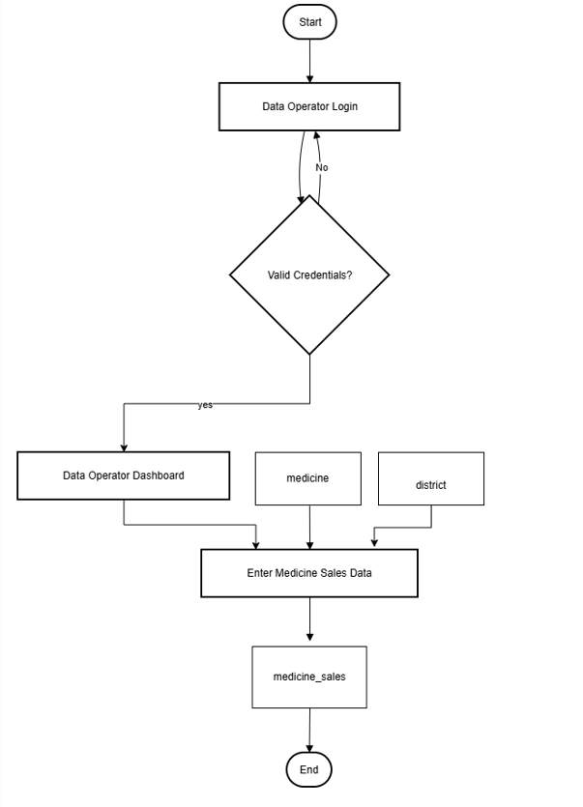

Figure 9.1.1

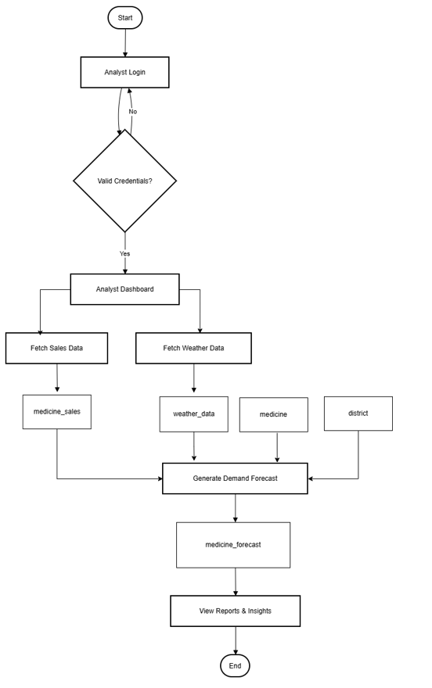**Analyst**:

Figure 9.1.2

**Admin:**

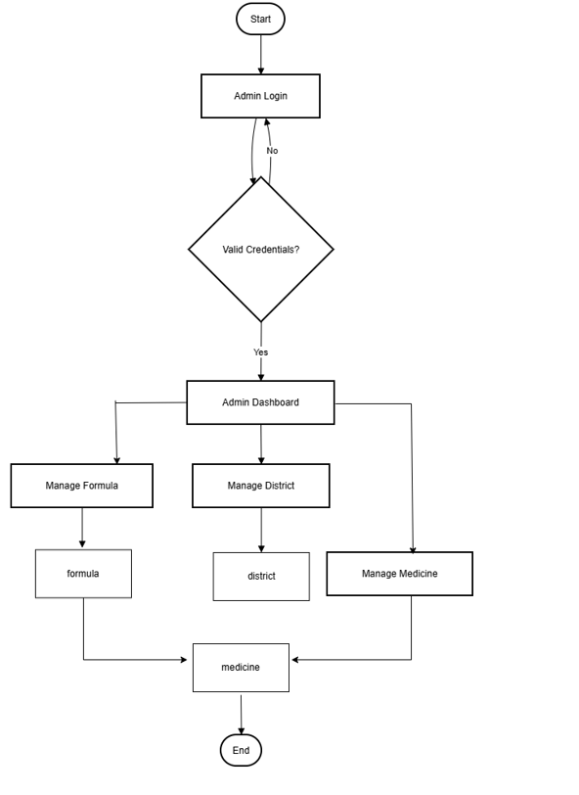

Figure 9.1.3

## UML Diagram

This UML diagram illustrates the object-oriented design of the Medicine Demand Forecasting System by defining the relationships among core entities and system services. Key data entities include Medicine, Formula, District, and Medicine Sales, which collectively represent the transactional and structural data of the system. The Forecast Engine acts as the central service, integrating sales and weather data to generate Medicine Forecast records. Supporting services such as Authorization Service manage user authentication and role control, while the Report Service handles the generation of forecast reports. Weather Data serves as an external data source, completing a modular and well-structured model that clearly represents system data flow and business logic.

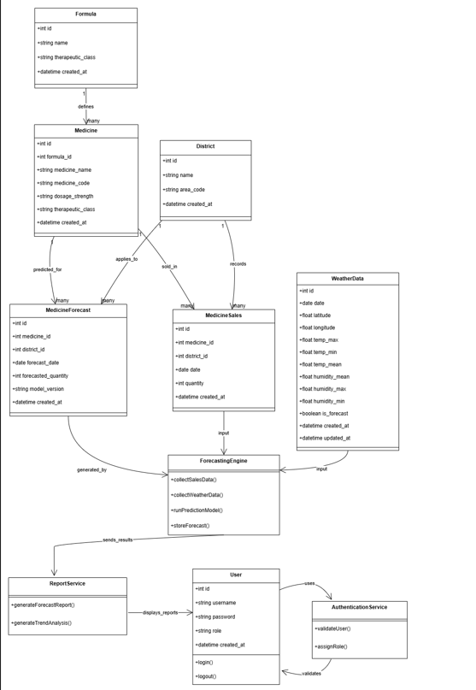

Figure 9.2

## Context Diagram:

This diagram illustrates the interactions between the primary users of the Medicine Demand Forecasting System. The Data Operator manages core functions such as login, dashboard access, and sales data entry, while the Administrator has full control over master data, user role management, activity log monitoring, and forecast report generation. The system handles three main types of requests: authentication, data processing, and forecasting operations, clearly defining the boundaries and data flows between external users and internal system components.

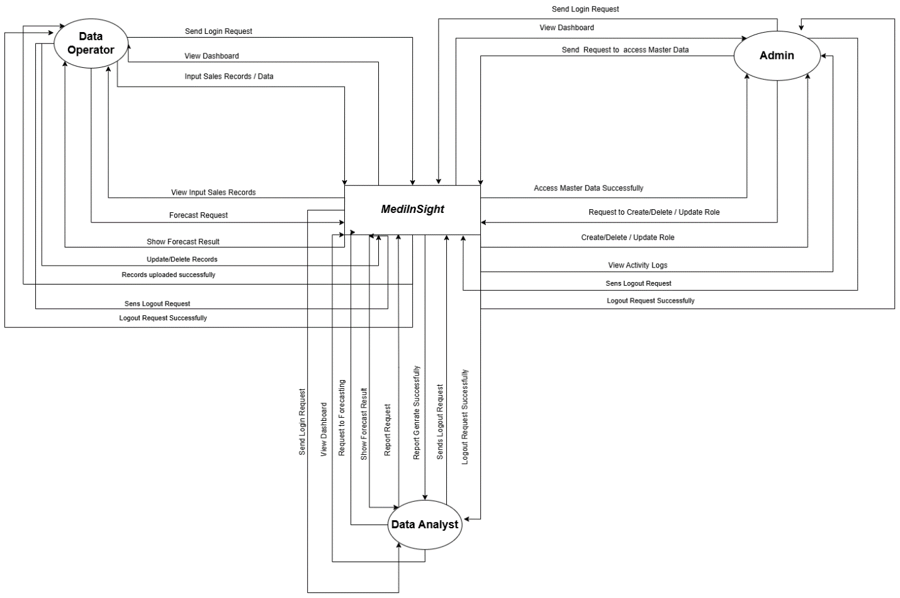

Figure 9.3

## Sequential Diagram

The sequence diagrams illustrate three distinct interaction flows within the Medicine Demand Forecasting System. The Forecasting System's sequence involves fetching historical sales data, requesting and storing weather information from an API, running the prediction model, and finally generating and delivering the forecast report. For the Data Operator, the sequence is linear: successful login authentication followed by sales data entry and confirmation. The Admin sequence is more complex, beginning with authentication and proceeding through multiple validation steps to create or update core master data like districts, formulas, and medicines, with each operation requiring specific checks and returning a confirmation.

**Analyst:**

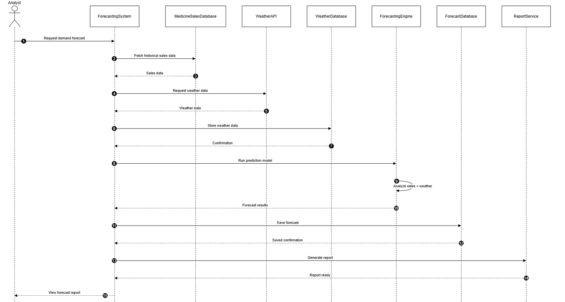

Figure 9.4.1

**Admin**:

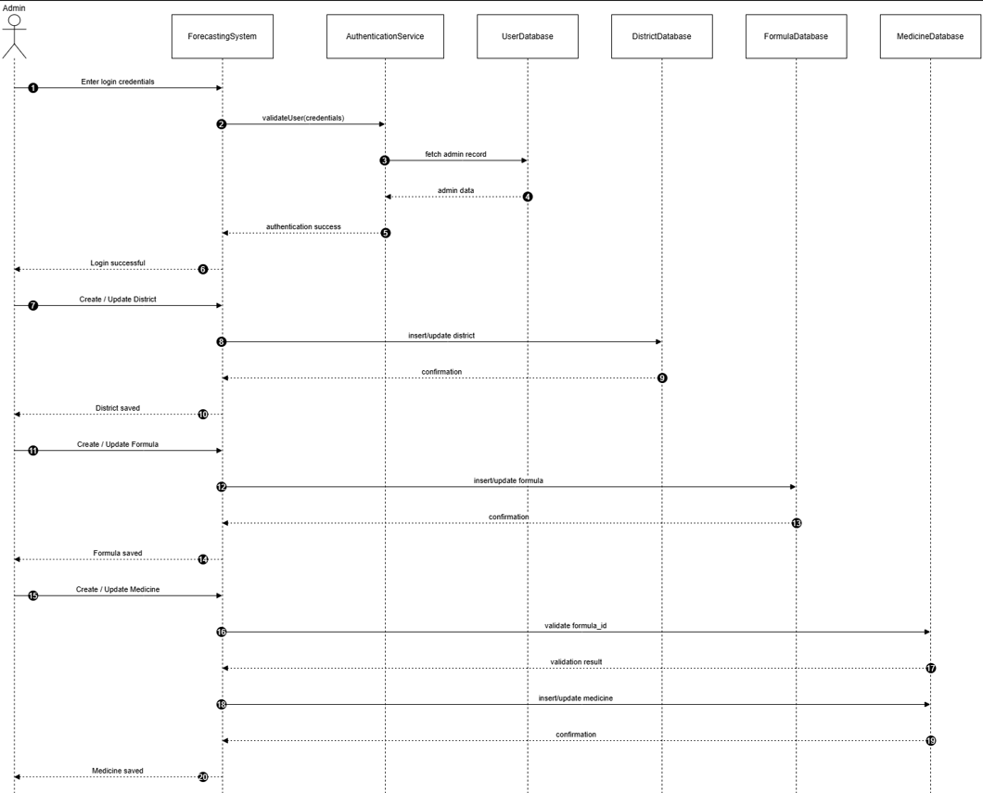

Figure 9.4.2

**Data Operator:**

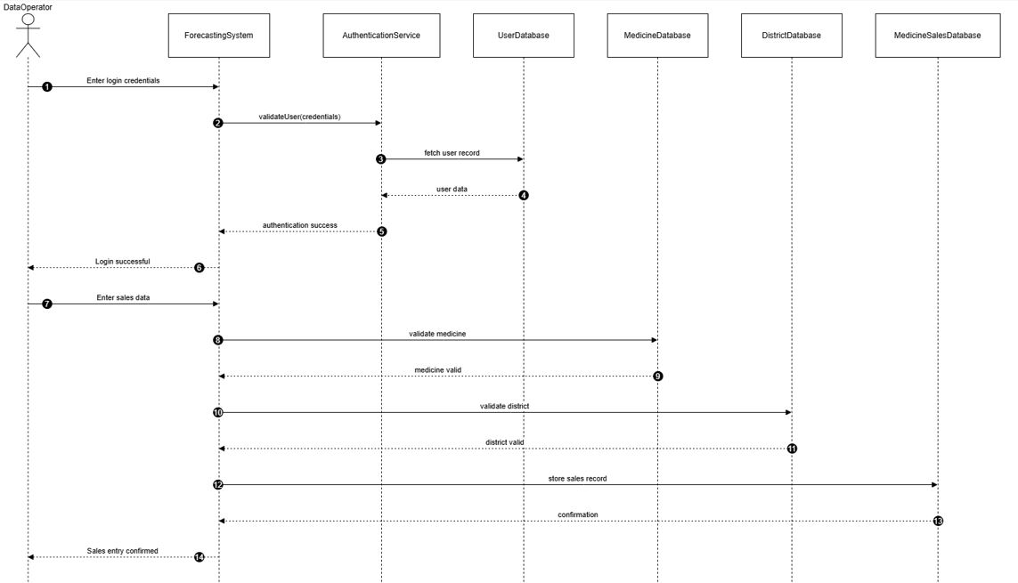

Figure 9.4.3

## ERD Diagram

This Entity-Relationship Diagram illustrates the database structure of the MedInsight System, which forecasts medicine demand based on weather conditions. It shows relationships between core entities: Medicine, Sales Records, Weather Data, Areas, and Forecasts. The schema is designed to support accurate weather-integrated demand predictions and efficient inventory management, enabling timely medicine supply and reduced shortages.

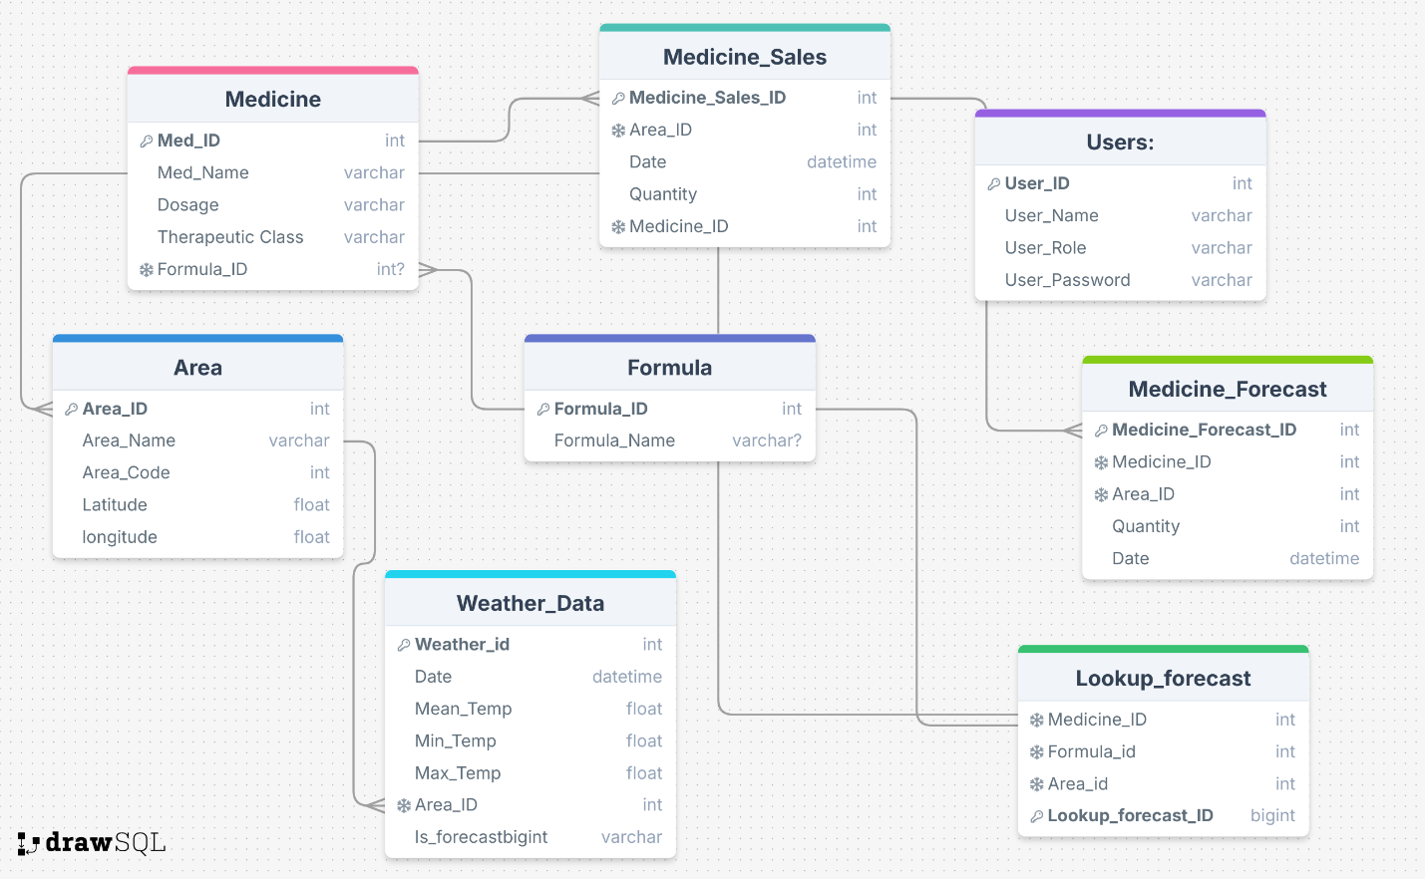

Figure 9.5

## Actor Diagram

The diagram shows the three main actors of the MedInsight System: Admin, Data Operator, and Data Analyst. Each actor performs specific tasks such as managing users and system settings (Admin), updating inventory and uploading weather data (Data Operator), and running forecasts and analyzing demands (Data Analyst) to support accurate medicine demand predictions.

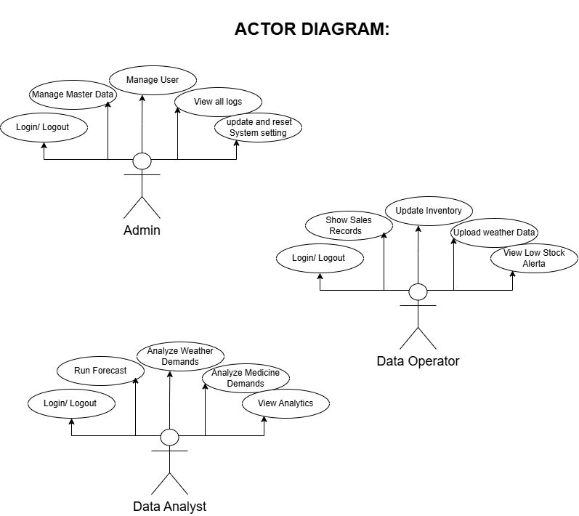

Figure 9.6

## Block Diagram

The system architecture is based on a modular block process flow structure, which begins with User Authentication to provide secure role-based access. Sales data and weather data are then processed by the Data Input Preprocessing module to be stored in Database Management. Finally, data analysis by Forecasting Engine produces expected demands for medicines according to weather data outputted by the Dashboard module. Finally, insights and warnings are delivered by the Alert Notification module to complete a fully functional process from data to request takeaways.

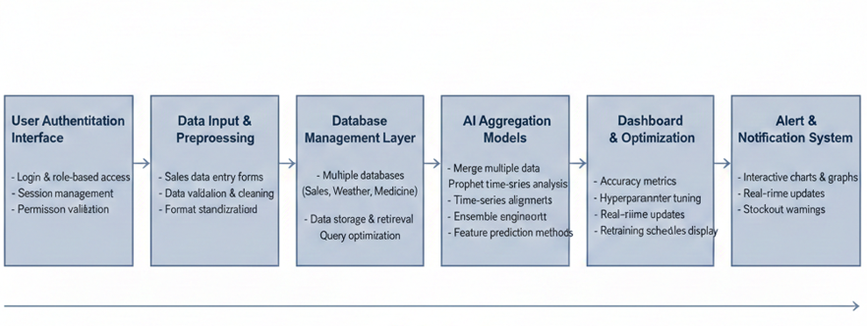

Figure 9.7

## Gantt chart

This Gantt chart provides a detailed one-year project plan for the development of the Medicine Demand Forecasting System with respect to weather patterns. The initial stages of this project involve requirement analysis and planning, then database design, weather data implementation, and development of forecasting models. The next stages of this project involve implementation, testing, and evaluation of the system. Some of the prominent events of this project include the completion of a functional forecasting system, improvement processes, and implementation of the system.

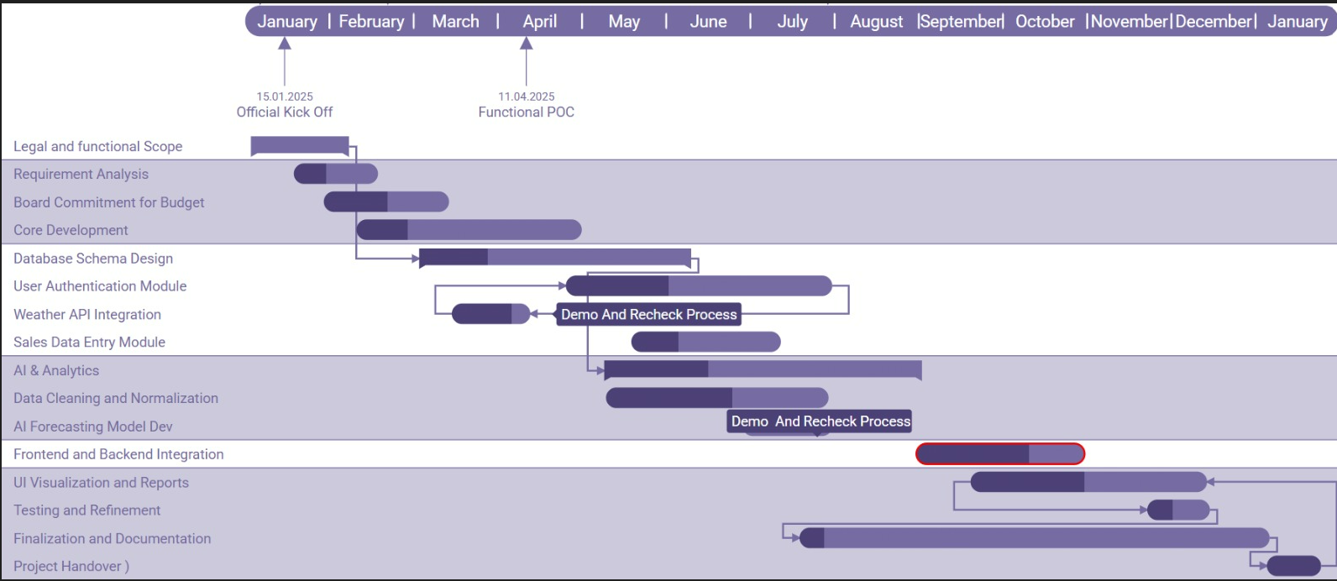

Figure 9.8